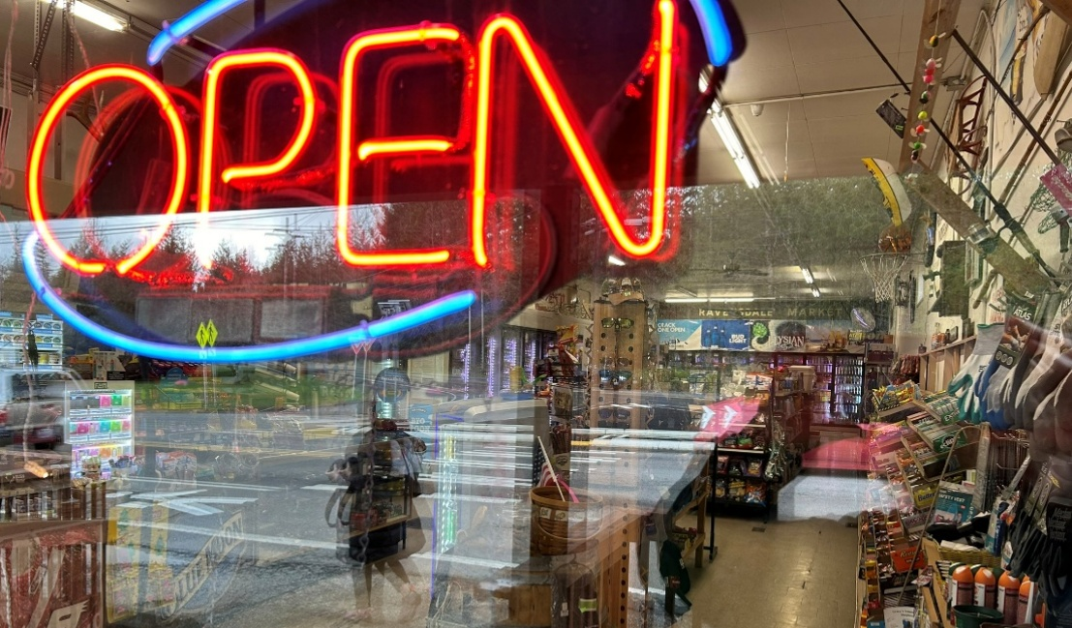

Chapter 10: Economic Development
The subarea is primarily comprised of Rural Lands and Natural Resource Lands, each of which plays a role in King County’s diverse economy. The Greater Maple Valley/Cedar River subarea maintains its rural identity, with much of the subarea dedicated to resource-based economic activities, including industrial uses, mining, forestry, and outdoor recreation.
The King County Comprehensive Plan says that economic growth must be focused within the Urban Growth Area (UGA) in cities and regional growth centers while focusing “rural economic development on sustaining and enhancing prosperous and successful rural and resource-based businesses, and on encouraging new businesses that support and are compatible with the rural economy, particularly in Rural Towns.”

Employment
Figure 15 offers a snapshot of reported jobs across different sectors in the Greater Maple Valley/Cedar River subarea, where total covered employment is currently estimated at just under 3,000 jobs. In line with the King County Comprehensive Plan, substantial job growth is not expected in this area.
Data from the Puget Sound Regional Council show that employment in the subarea has fluctuated over the past two decades. Since 2000, the unincorporated portion of the subarea has added approximately 1,110 jobs—reflecting a 4 percent annual growth rate between 2010 and 2023.
The incorporated cities of Maple Valley, Covington, and Black Diamond each have their own commercial areas located outside the subarea within the Urban Growth Area, and these serve as the commercial hubs of this area of King County. Due to the methods used for collecting and publishing certain economic and employment data, activities within these cities may occasionally be combined with the subarea's statistics.

Figure 20 Puget Sound Regional Council Covered Employment Estimates: Greater Maple Valley/Cedar River area*
Year | Construction  Resources | FIRE** | Manufacturing | Retail | Services | WTU** | Government | Public Education | Total
2000 | 918 | 22 | 22 | 45 | 368 | 54 | 152 | 288 | 1,870
2010 | 524 | 21 | 29 | 53 | 784 | 41 | 159 | 222 | 1,832
2020 | 1,051 | 31 | 18 | 326 | 845 | 59 | 145 | 272 | 2,747
2023 | 994 | 52 | 28 | 361 | 982 | 151 | 131 | 285 | 2,984
Percent of 2023 Total | 33% | 2% | 1% | 12% | 33% | 5% | 4% | 10%

* “Covered employment” refers to positions covered by the Washington Unemployment Insurance Act. Data excludes most nearby cities.
**FIRE = Finance, Insurance, and Real Estate
**WTU = Warehousing, Transportation, and Utilities

Rural Neighborhood Commercial Centers
The Greater Maple Valley/Cedar River subarea does not contain any Rural Towns—small, historically established communities located outside the Urban Growth Area (UGA) and designated in the Comprehensive Plan.
However, the subarea features Rural Neighborhood Commercial Centers (RNCCs). King County identifies five RNCCs through the Comprehensive Plan. These centers are small-scale commercial areas located within rural parts of the county. They are intended to provide essential goods and services to local rural residents without encouraging urban-style growth or development. The Comprehensive Plan says that no new RNCCs are needed, but existing centers may be enhanced and maintained. Chapter 4, Land Use, addresses the RNCC-designated parcels in more detail.
Following are examples of commercial businesses and services in the RNCCs of Greater Maple Valley/Cedar River:
RentonMaple Valley Road SE/State Route 18 RNCC: gas station, pizza restaurant, grange, antique shop, coffee shop, real estate office, food bank, social services, youth sports headquarters, towing company.
Ravensdale RNCC: convenience store, self-storage, taxidermy business, financial advisor, snowmobile repair, sign shop.
Hobart RNCC: food market and post office.
Kanaskat RNCC: former tavern, former kayak rental; currently no active commercial business licenses.
Kangley RNCC: currently no services or commercial businesses.

Worker Commuting Patterns
Many residents of the Greater Maple Valley/Cedar River subarea commute to major employment centers across the region. As shown in the map in Appendix A, nearly 70 percent of subarea residents travel to cities like Seattle, Kent, Bellevue, and Renton for work or services. This pattern reflects the subarea’s primary role as a residential community rather than an employment hub, and emphasizes the limited number of local job opportunities within the subarea itself.

Forestry
Over 83 percent of the subarea, approximately 183,100 square miles, lies within the Forest Production District, which spans nearly the entire eastern portion of the subarea and includes a mix of private and public landowners. Many private landowners actively manage their properties for forest resource production, contributing to the local economy through timber harvesting. BTG Pactual-Timber Investment Group and Weyerhaeuser are the two most prominent private landowners engaged in commercial forestry operations in the subarea. Between 2019 and 2025, there were 150 active harvest applications covering over 4,000 acres.

Industrial Lands/Mineral Resources
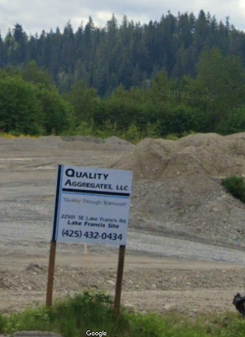
The subarea contains seven designated mineral resource sites and five potential surface mineral resource sites, with several additional sites located along its borders. These areas are managed to balance the economic benefits of resource extraction with environmental protections. Extracted materials like sand, gravel, and crushed rock are vital for both public works and private construction projects, supporting local employment and contributing to public revenues.
Image 27 Mineral Resource Site
King County permits mining activities only on land designated with specific zoning (Mining, Forest Production) and restricts such activities in environmentally critical areas. The Washington Department of Natural Resources (DNR) oversees permitting and regulation of these sites, ensuring compliance with environmental protections and proper land reclamation practices.

Community Priorities
The focus of planning for the Greater Maple Valley/Cedar River subarea is in King County’s unincorporated rural area. Business development is limited in rural areas, and members of the community express support for local businesses that reflect the “rural way of life” which is characterized by a close connection to nature, low population density, small farms, and limited commercial businesses. Following are priorities heard throughout the planning process.
- Retain the character of rural businesses. Community members emphasized supporting local businesses that provide essential goods and services and reflect the community’s character and needs while maintaining the rural scale of existing commercial areas. This includes farms, nurseries, equestrian businesses, small stores and services, home-based businesses for craftspeople and professionals, and recreational enterprises.
- Support small, locally-owned, and home-based businesses. Residents expressed a preference for economic growth driven by local entrepreneurs and workforce development, prioritizing support for existing businesses over the introduction of large corporations and franchises.
- Do not Significantly Expand Existing Commercial Centers. Residents of the subarea expressed a desire to retain the general boundaries of the RNCCs, which serve as small-scale commercial hubs for the rural community. That said, some people expressed a desire for small and locally-owned retail, entertainment, and food service activities that serve residents in the community. Possible uses of RNCCs zoning for housing is also a concern that has been expressed.
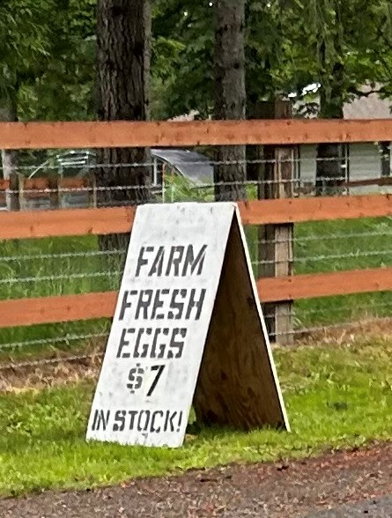
- Concerns about expansion of mining and industrial activities that impact the community or degrade the environment. Residents opposed the expansion of mining and industrial activities. A primary concern was the impact of existing mining and industrial sites on neighboring properties, including potential environmental, air quality, noise, and traffic effects.
Image 28 Small Scale Agricultural Activity
- Support for agricultural activities. Many people expressed support for small farms and agricultural-related businesses. Some of these businesses provide a source of fresh produce, eggs, and other food for residents.

- Concerns about “agricultural tourism” in the rural area. Many people are concerned about agricultural tourism. It is not well defined and the effects on the rural area unknown. There have been negative impacts from similar activities such as event centers and beverage tasting rooms.

Policies

GMVCR-19 Serve the essential goods and services needs of the subarea at a scale and intensity appropriate to the rural area by limiting the expansion of the Rural Neighborhood Commercial Centers in the Greater Maple Valley/Cedar River subarea.
GMVCR-Ch10a Mining, and the associated mine reclamation, will be planned and organized in advance, with regular progress reports submitted and sites regularly monitored. Progress and inspection reports will be publicly available. The public will have the opportunity to provide comment on any significant changes in the mining or mine reclamation plans.
GMVCR-Ch10b Study methods for small scale agricultural producers to reach customers, such as access to farmer’s markets without renting full spaces. Create or improve incentives for reduction of waste, use of local labor, improving productivity for agricultural activities, and for educational and assistance programs.
GMVCR-Ch10c Support the importance of teaching entrepreneurialism in the education system. Review ways to better emphasize vocational skills in education curricula.
GMVCR-Ch10d Provide incentives for small farms and agricultural-related small businesses to succeed.

GMVCR-Ch10e Ensure Rural Neighborhood Commercial Centers are exclusively limited to rural businesses, not housing.

2024 Comprehensive Plan Policy ED-104
Puget Sound Regional Council Covered Employment Estimates [Link]
King County’s GIS information on commute patterns is derived from American Community Survey and Longitudinal Employer-Household Dynamics data.
WA Department of Natural Resources Forest Practices Applications – Active Harvest by Classification, 2025. [LINK]
King County, Clearing and grading permits. King County Department of Local Services. [Link];
Washington State Department of Natural Resources, Aggregate Resources. [Link]

