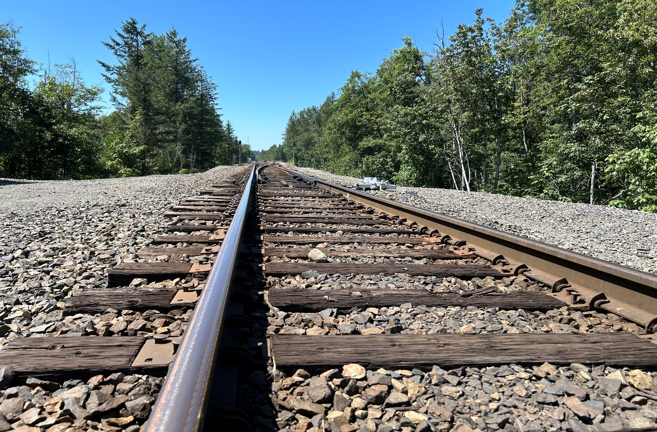

Chapter 11: Subarea Plan Implementation
King County is committed to putting the community’s vision into action through the policies in the subarea plan and in the King County Comprehensive Plan. As part of adopting the plan, the County has made updates to the Land Use and Zoning Maps. Looking ahead, the County will continue working with the community to refine the Community Needs List and will use performance measures to track progress on implementing the plan.
Making the community’s vision a reality will take ongoing collaboration between community members and the County. It also means balancing different priorities to guide decisions and investments. Implementation happens through the County’s budget — developed by the Executive and approved by the King County Council — through policy direction from the Council, and through continued work by County departments.

Land Use and Zoning Map Amendments
To implement the land use-specific policies of this subarea plan, two categories of land use and zoning map amendments will be considered:
- Several parcels are the subject of zoning reclassification (rezone) or Comprehensive Plan land use re-designation.
- Development conditions that apply to parcels in the subarea may also be updated. Development conditions are regulations that apply to permitted development on specific properties. Examples of development conditions include standards for allowable activities or permit requirements.

The map below illustrates areas under consideration for zoning, land use, and map amendments. These areas are highlighted and labeled in red. Proposed land use, zoning, and map amendments will be further refined prior to release of the Public Review Draft of the Greater Maple Valley/Cedar River Subarea Plan.

Lake Youngs
Lake Youngs perimeter properties are being considered for rezone from Rural Area (RA) to Forest (F) to align with the Forestry (f) land use designation, and to ensure protection of the Lake Youngs reservoir and the surrounding forest ecosystem.

Repeal or Revision of Development Conditions
Several property-specific development conditions in the subarea have been in place since the mid-1990s or earlier. Five of the conditions may be repealed as the conditions have been satisfied or other regulations are in place that meet or exceed the property-specific conditions. Additionally, two property-specific development conditions may be amended to reflect current regulations and references.

Renton Maple Valley Road SE and SR 18 RNCC
Four properties in this area are being considered for land use redesignation or rezoning to address inconsistencies between zoning classifications and land use designations, or where zoning and/or land use designations apply to only part of a property.

Kangley RNCC and Kanasket RNCC
These Rural Neighborhood Commercial Centers are being considered for rezones and land use re-designation from commercial zoning to rural area zoning and land use. In all cases, property boundaries have changed, and historic commercial uses may no longer be present. The RA zone would continue to allow limited commercial use.
Ravens Corner
Per KC Hearing Examiner’s recommendation of May 25, 2023 (LUT42000002) that the GMV-CR Subarea Plan specifically look at the Ravens Corner property (Parcel 302207-9009) and determine “whether: (a) RA-10 is still the most appropriate zoning, (b) the rural forest focus area should continue to apply there, and (c) because the Retreat [i.e., the adjacent King County Ravensdale-Retreat Natural Area (RRNA)] is not slated to be used as commercial forestry, the northern boundary of the Forest Production District [which currently includes the RRNA] should be moved south to the railroad corridor [to exclude the RRNA].” The community has presented very compelling arguments that: (a) RA-10 zoning is still the most appropriate zoning for this (and similar) property; (b) the Cedar River/Ravensdale Rural Forest Focus Area should remain intact, as-is; and (c) the Forest Production District (FPD) boundaries should NOT be altered just because a particular tract (e.g., the Ravensdale-Retreat Natural Area) is not being managed primarily for the commercial production of traditional forest products (logs and chips for wood and paper products). As long as the properties falling within the FPD are being managed primarily for either traditional commercial forest products and/or ‘ecosystem services’ (e.g., habitat, recreation, air and water quality, stormwater control, soil stability, scenic and spiritual amenities, carbon sequestration, climate change amelioration, etc.) they should remain within the FPD. [Note: the KC Council should refine KC Code and Policy to clarify that forests within the FPD need not be managed primarily for the commercial production of timber. The reality is that the vast majority of lands within King County’s FPD are no longer so managed. The Hearing Examiner also suggested the Council may want to reconsider whether ¼ mile is still the appropriate buffer around FPD lands; and consider rewording the “predominant lot size” and “predominant lot pattern” language in KCC 21A.04.060.B.3, and R-306 & R-308 to avoid ambiguities that could lead to unintended decisions.]

Figure 21 Preliminary Zoning and Land Use Map Amendment considerations
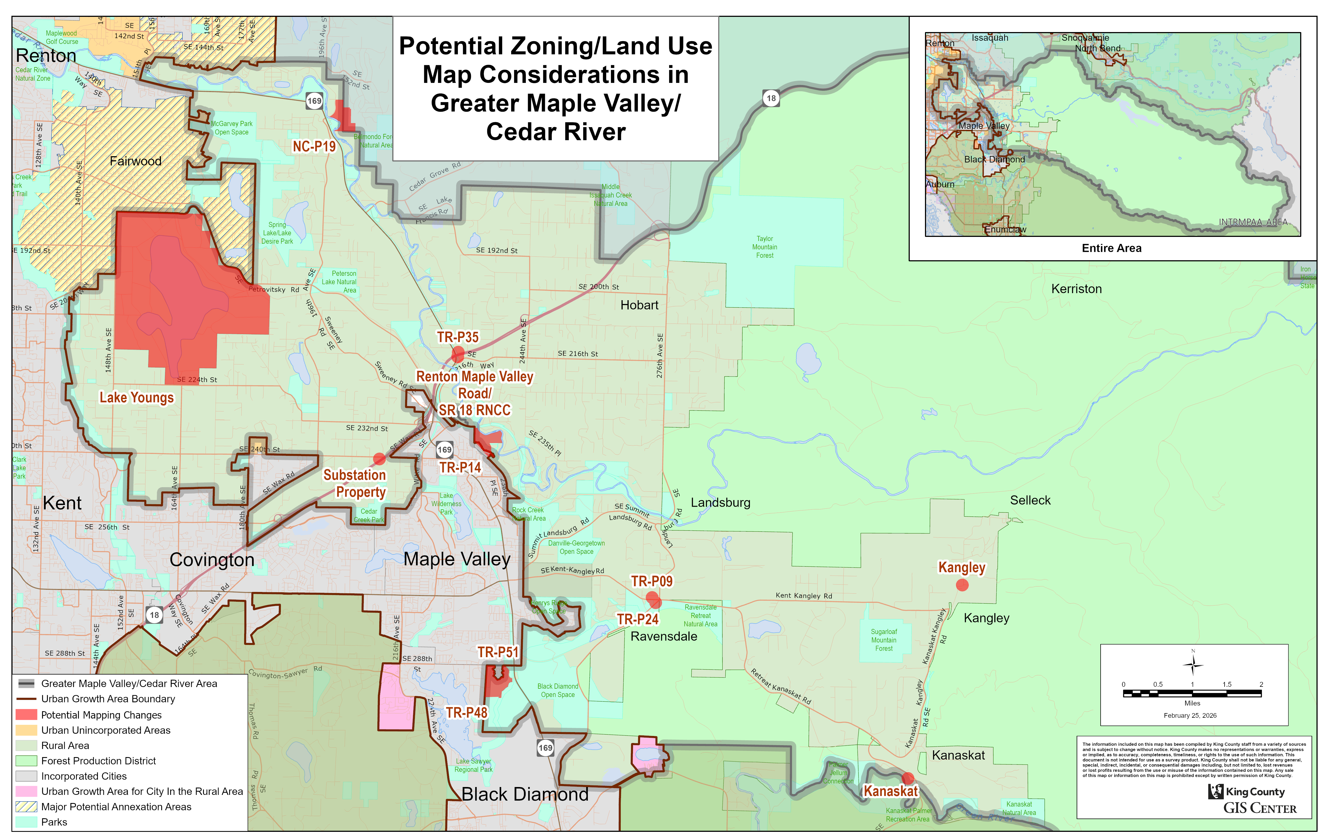

Parks and Open Space

Regional Trail Needs Report
The 2026-2031 King County Parks levy has allocated $18 million to undertake planning efforts for future regional trail connections, including regional trails that serve the subarea. Regional and local trails will be evaluated by King County DNRP for future investments.

Transportation

Road Services Work Program
King County conducts a wide range of projects to maintain and improve the safety and longevity of the county road system, as detailed in the Strategic Plan for Road Services(ref?). A large portion of this work program occurs in the Greater Maple Valley/Cedar River subarea. Major categories of work include pavement preservation, bridge maintenance and repair, traffic operations, safety investigations, situation responses, and other analyses. As detailed in the Strategic Plan, this work program is heavily constrained by limited finances. After about 2029, foreseeable funding will be insufficient to continue all current maintenance activities, with no funds for any of the capital improvements identified in the Transportation Needs Report (KC should provide specific reference here).

Metro Transit Work Program

Metro Transit's long-range plan allows for increased area coverage and service frequency countywide, as grow occurs. This may include future service expansion in the Greater Maple Valley Cedar River subarea, consistent with available budget. In order to achieve the level of service increases requested by area residents, Metro could consider adjusting the criteria used for allocation of services to all areas of the county, or seek additional funding sources. Foremost among these considerations would be to reduce climate impacts of commuter travel by increasing transit service between the isolated outlying cities of Black Diamond, Enumclaw, Buckley, and Bonney Lake and the urban core cities of Auburn, Kent, Renton, Issaquah (and beyond). While such action would primarily serve the important regional goal of reducing climate impacts, the Greater Maple Valley/Cedar River subarea would also benefit to the extent that intercity traffic through the subarea is reduced.

Active Transportation
Subarea residents desire better roadside (i.e., shoulder) conditions for pedestrians, bicyclists, and equestrians; however, existing financial resources do not allow for such improvements even though nearly all county roads fail to meet the county road design standard (eight feet) for shoulder width. The road design standard should be updated to allow a variable width of shoulder versus traffic volume, sight distance, and other considerations, to serve all road users and to permit interim improvements at lower cost. This will provide design guidance for implementing the county's Complete Streets Ordinance as funds become available for future road reconstruction.

Heavy Truck Operations (Haul Roads)
Procedures should be developed and adopted that assure coordination between the Road Services Division and the Permitting/Code Enforcement Division such that any mining or industrial activity that generates heavy truck traffic is required to use specified county roads to connect with state highways, is subject to monitoring and effective penalties for non-compliance, and pays appropriate fees for reconstruction of county roads to repair the damage caused by said activity over time.

Financial Reform

The structural deficiencies of the county road fund mean that most needed road improvements cannot be funded, leading potentially to catastrophic failures of bridges and roads. Efforts must continue to seek additional revenues for this fund, so as to overcome the forecast $2.4 billion shortfall detailed in the Strategic Plan for Road Services. The majority of road usage in the county's rural areas is by intercity travelers, not rural area travelers, and intercity travel underlies the majority of needs for reconstruction of many rural roads and bridges; however, the county road fund receives no revenues from city residents outside the rural area. Meaningful financial reform must therefore include compensation for the high proportion of rural area road use by intercity travelers.

SR169 Corridor/Subarea Traffic Study
King County will seek to involve other affected cities, the state, and regional agencies in a wide-ranging multi-modal and interagency evaluation of transportation solutions to serve regional growth targets (VISION2050), to comply with subarea transportation goals for rural area preservation, to assess the impact on the region of growth plans in certain cities which exceed the region's adopted growth targets, and to investigate potential mechanisms to resolve the structural crisis of county road financing. The study would be centered on SR 169 as the central artery of the subarea, but account for all other county arterials in the Greater Maple Valley/Cedar River subarea, the Southeast King County subarea, and the Four Lakes/Tiger Mountain subarea.

Coordination with Other Agencies
King County Roads coordinates with other King County agencies, the King County Sheriff’s Office, cities in the vicinity of the Greater Maple Valley/Cedar River subarea, and with the State of Washington Department of Transportation. A key focus of work is expanding access, addressing congestion, and increasing road safety in rural, unincorporated areas of King County.

Utilities

Broadband Access
King County will continue to pursue grant funding and partnership opportunities with telecommunications providers to expand and upgrade telecommunications infrastructure in the Greater Maple Valley/Cedar River area. For more information, reference King County’s Broadband Internet Access program.

Community Needs List and Budgeting
As part of its commitment to inclusive and responsive government, King County develops Community Needs Lists (CNLs) to capture local priorities for services, programs, and capital improvements. These lists reflect ideas and input from residents about what their communities need most, ranging from public safety and infrastructure to education, health services, and more.
Under King County Code, the Department of Local Services (DLS) is required to create 11 separate CNLs: one for each of the six rural Community Service Areas (CSAs) and one for each of the County’s five urban Potential Annexation Areas (PAAs).
Each CNL item includes a description of the need, a responsible agency, a proposed timeline, and prioritization. These lists are updated every two years and are submitted to the King County Council alongside the Executive's Proposed Budget.
While the CNLs help guide budget planning, funding is not guaranteed for every item. Implementation depends on the resources allocated in the final, adopted biennial budget—alongside other factors like departmental priorities and countywide strategic plans.
The Greater Maple Valley/Cedar River CNL was adopted with the 2026-2027 biennial budget and reflects local priorities to improve quality of life in the Greater Maple Valley/Cedar River subarea. Key goals include expanding youth mental health services, after-school programs, and childcare support; investing in community spaces like parks, trails, and a Ravensdale community center; and improving public safety through increased law enforcement and traffic calming. It also calls for better transit options, trail connections, environmental restoration, public health education, food access programs, and more community events and outreach.

Performance Measures
King County will track progress on the subarea plan using performance measures that show how well the County is meeting community goals and priorities. These measures help ensure accountability and make it easier to see what’s working—and where more attention is needed. Find a copy of the first Subarea Plan Performance Measures Report on King County’s subarea plan website.
Fourteen performance measures have been established: six apply to all rural unincorporated subareas, allowing comparisons across the county, and eight are specific to the Greater Maple Valley/Cedar River subarea, reflecting local values and priorities. Over time, these measures may be refined to better reflect progress toward community outcomes. When possible, data will also be broken down by race and ethnicity to understand how different communities are being served.

Standardized Rural Unincorporated Performance Measures
The following standard measures apply to each planning subarea. They will be tracked at the subarea level to provide a numeric snapshot of subarea plans’ performance over time. These measures have already been approved by the County Council and the Executive through the 2024 Comprehensive Plan Ordinance 19881.
Standard King County Performance Measure | Data
Development preserves rural character | - Total population  - Number of residential units permitted, including size of structures
The economy is balanced and resource-based | - Number of jobs and businesses, by sector
Housing is diverse and affordable | - Housing units by type  - Percent of households paying more than 30 percent of income for housing costs  - Percent of households paying more than 50 percent of income for housing costs
Peak hour travel is not degrading faster than growth | - Change in corridor peak hour travel times on major routes compared to population and job change
Farms and forest lands are protected | - Change in total APD and FPD acreage, including acreage permanently privately protected or in public ownership
Ensure residents and businesses have adequate access to broadband internet service | - Number and percent of households with broadband service  - Number and percentage of households that are unserved or underserved with broadband service

Draft Greater Maple Valley/Cedar River Measures
Eight draft subarea-specific performance measures are proposed for the Greater Maple Valley/Cedar River subarea. Along with the standard measures, these will help track progress in implementing the subarea plan. The measures are intended to rely on data that can be consistently collected and replicated from year to year.
Draft Greater Maple Valley/Cedar River Performance Measure | Data
Maintain rural economic vitality and character | - Quantity of commercial permits and area of newly permitted commercial space in RNCCs  - Quantity of Temporary Use Permits issued within the subarea  - Quantity of Home-Based businesses.
Strengthen access to recreation opportunities | - Inventory and linear miles of regional and backcountry trails and passive recreation opportunities
Protect habitat, riparian areas, and increase resiliency from flooding and other natural hazards | - Linear feet and acreage of restored riparian habitat in WRIAs 8 and 9 within the subarea  - Number and duration of road closures during flood events  - Number of flood events that impact dams and livestock

Improve mine permitting, reclamation and code enforcement | - Number of mining permits without definitive Development Conditions that include specific reclamation requirements and timing  - Number of mines where mining has ceased, but reclamation is out of compliance with permit Development Conditions - including reclamation completion  - Number of parcels where mining is completed and no further reclamation is required, but County data and maps have not been updated to the post-reclamation Land Use, Zoning and Resource Type  - Number of active mines where the last KC on-site monitoring visit for compliance with KC code, policy, and permit conditions is more than 5 years old  - Number of mining permit renewal approvals where conditions are out-of-compliance with KC code, policy, and permit conditions
Reduce/Eliminate vehicle-pedestrian/bicyclist accidents and reported close-calls | - Number of investigated, and number of reported accidents/close-calls.
Improve Law Enforcement response & effectiveness | - Response times by category of seriousness/urgency of call  - Effectiveness of response in terms of outcomes
Preserve key cultural/historical community assets | - Number and significance of community assets protected by KC Historical Preservation (KCHP) group  - Number of community assets evaluated by KCHP and judged to be significant that were lost or seriously degraded  - Histlorical Museums’ rating (subjective 1 – 10 scale) of KC’s level of support
Encourage rural residential forestry through support of the Cedar River/Ravensdale Rural Forest Focus Area. | - Number of 20+ acre parcels within CR/R RFFA  - Number of 10+ acre parcels within CR/R RFFA where forest cover was reduced to <65%

King County Road Resurfacing Project [LINK]
King County Boradband Internet Access [LINK]
2.16.055.C.1. Rural community service areas: Bear Creek/Sammamish, Four Creeks/Tiger Mountain, Greater Maple Valley/Cedar River, SE King County, Snoqualmie Valley/NE King County, and Vashon/Maury Island. Urban potential annexation areas: East Federal Way, East Renton Highlands, Fairwood, North Highline, and Skyway/West Hill
2024 Subarea Plan Performance Measures Report. [LINK]

