Chapter 2: Community Engagement, Vision, and Guiding Principles
The Greater Maple Valley/Cedar River Subarea Plan is intended to reflect the voices, values, and aspirations of the people who live, work, and spend time in this unique part of unincorporated King County. Developed through a robust community engagement process, the plan is shaped by local knowledge and grounded in the priorities shared by residents in a variety of meetings, surveys, workshops, and conversations.
At the heart of the plan is a community vision, a forward-looking statement that captures how residents hope their community will grow and change over the next 20 years. This vision is supported by a set of guiding principles that reflect shared goals.

Community Engagement
Community engagement played a central role in shaping the Greater Maple Valley/Cedar River Subarea Plan. King County worked closely with residents, community groups, and local organizations to ensure the planning process was inclusive, transparent, and grounded in local priorities. This level of engagement is consistent with Chapter 11 of the Comprehensive Plan, which says that “Subarea plans are developed in close coordination between the community and County staff…”
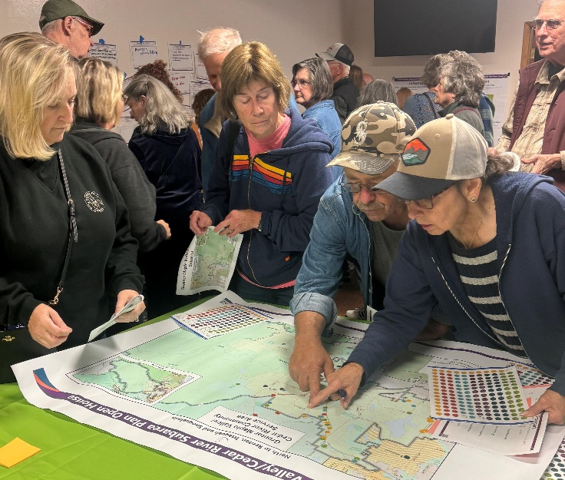
Engagement began in 2024 and continued through early 2026, using a range of engagement methods such as online surveys, in-person and virtual meetings, interviews, and open houses. These efforts created multiple opportunities for community members to share their perspectives, identify priorities, and provide feedback on draft ideas and policies.
Image 9 Open House - September 2024
Special focus was placed on reaching historically underrepresented voices, including youth, seniors, low-income households, and communities of color. King County used equitable outreach strategies—such as partnering with community connectors, faith-based organizations, and cultural groups—to make participation more accessible and meaningful.
Input gathered throughout this process directly shaped the community’s vision and guiding principles, community priorities, and policy direction. This collaborative approach ensured that the plan centers equity and social justice principles and reflects the lived experiences and hopes of the people who call the subarea home.
The Greater Maple Valley Unincorporated Area Council (GMVUAC) lent its support and was involved in every phase of this subarea plan’s development.
For a complete description of engagement activities, see Appendix C.

Phase 1: Scoping Community Priorities
Summer 2024 – Autumn 2024
During Phase 1 of engagement on the Greater Maple Valley/Cedar River Subarea Plan, the Department of Local Services initiated a comprehensive community engagement process to gather input from residents and other community members. A kickoff event took place on September 26, 2024, at the Hobart Community Church, attracting over 120 attendees. Participants engaged in interactive activities, including mapping exercises and visual feedback sessions, to express their priorities and concerns. Topics discussed encompassed housing, transportation, parks, cultural resources, and land use. An artist was present to capture community feedback through live illustrations, providing a unique and engaging way to document discussions.
In addition to the open house, the County launched an online survey to further collect community input and requested feedback to guide the plan’s development on the PublicInput website, an online engagement platform which served as the main information website for the Greater Maple Valley/Cedar River Subarea Plan.

Getting the Word Out
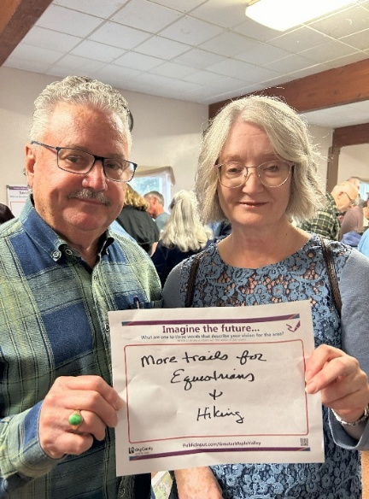
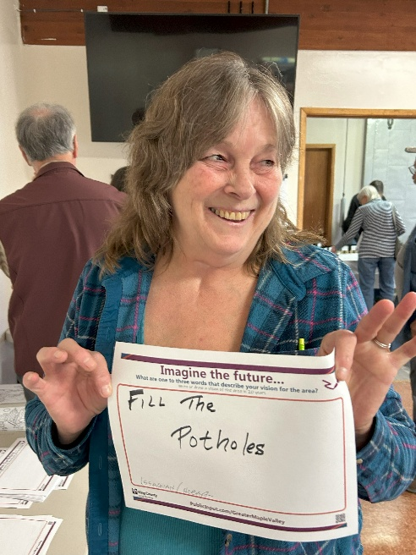
Notice of meetings, surveys, and other opportunities to provide feedback were provided in the following ways:
Image 10 Open House -September 2024
- Department of Local Services website
- PublicInput.com
- Social media (Facebook, Instagram, NextDoor)
- King County Unincorporated Area News email newsletter
- GovDelivery email list for Greater Maple Valley/Cedar River
- King County Council District 9 newsletters and messaging
- Announcements by local community organizations such as Greater Maple Valley Unincorporated Area Council
- Posting fliers at local businesses, community centers, and faith-based organizations
- Mailing postcards to all mailing addresses in the subarea
In addition, Department of Local Services staff actively reached out to local organizations and government entities to ensure broad participation and gather diverse perspectives.​
Find the entire Phase 1 Summary at the following link: Phase 1 Report

Phase 2: Preliminary Planning
Winter 2024 – Autumn 2025
During Phase 2, King County staff sought more detailed information on community priorities and undertook equitable engagement to reach historically underrepresented community members.

Community Conversations
The Department of Local Services hosted a series of five open-house style meetings in spring 2025 to gather community feedback on specific subarea-wide topics addressed in the subarea plan. Between 25 to 30 people attended each event, which focused on the following topics that correspond to chapters in the plan:
- Equity, Vision and Principles
- Environment, Parks and Open Spaces
- Economic Development, Housing and Human Services
- Land Use and Zoning, Services and Utilities
- Transportation

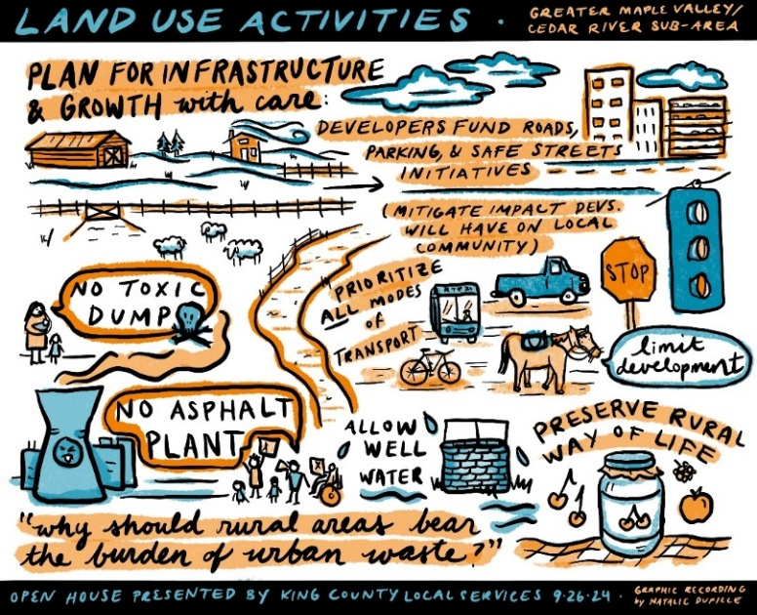
Getting the Word Out
Image 11 Artist Natalie Dupille captured feedback from members of the community at the 2024 open house event
Engagement for Phase 2 included many of the same elements used during Phase 1.
- Department of Local Services website
- PublicInput.com
- Social Media (Facebook, Instagram, NextDoor)
- King County Unincorporated Area News email newsletter
- GovDelivery email list
- King County Council District 9 newsletters and messaging
- Announcements from local community organizations
- Posting fliers at local businesses

Engagement with “Voices to be Heard” Communities
During the spring and summer of 2025, staff engaged with individuals from historically marginalized communities in the Greater Maple Valley/Cedar River area to better understand their lived experiences, priorities, and visions for their neighborhoods. These communities were intentionally prioritized, as they have often been excluded from governmental and planning processes, and their perspectives have not been fully represented in previous outreach efforts.
Referred to as “Voices to be Heard” communities, these populations include youth; seniors and elders; veterans; immigrants and refugees; individuals who identify as LGBTQIA+; people with low incomes or experiencing poverty; individuals who are unhoused and/or unsheltered; people with disabilities or accessibility needs; those who speak languages other than English as a primary language; and communities experiencing environmental injustices.
To support this effort, staff conducted interviews with seven community connectors—individuals who provide direct services to these communities in the area—as well as four individuals who personally identify with one or more of the Voices to be Heard groups.

Community Meeting and Review Planned for Early 2026
In April 2026, staff released a preliminary draft of the subarea plan and received public commentary on the draft. A complete report on community engagement will be published with the subsequent Public Review Draft report, anticipated later in 2026.

Vision and Guiding Principles
The community vision statement for the Greater Maple Valley/Cedar River Subarea Plan is an aspirational, forward-looking description of what the community hopes to achieve over the next 20 years. It reflects local values, priorities, and a shared desire for a future that meets the needs of residents while protecting the natural environment and rural way of life. Developed through ongoing community engagement, the vision defines what success looks like for the subarea and sets the tone for the rest of the plan.
Supporting this vision is a set of guiding principles that inform and shape the policies within the plan. Together, the vision and guiding principles provide a foundation for thoughtful decision-making that balances growth, conservation, and community well-being.

Community Vision Statement

The Greater Maple Valley/Cedar River community cherishes its rural character and open spaces; protects its forests, rivers, and wildlife; and fosters a welcoming environment for everyone to thrive. The community’s Rural Character will be supported by facilitating strong local ties and communication between the public, organizations, and government; promoting locally owned businesses and supporting quality education; protecting the environment, and maintaining landowners’ rights and responsibilities; promoting controlled and well-planned growth with appropriate infrastructure; ensuring proper representation for rural interests and needs; and supporting the health and safety and the privacy of our vibrant community.

Guiding Principles

- Preserve the unique character and integrity of the rural landscape and residential community.
- Ensure all residents have access to opportunities and needed services in nearby cities.
- Safeguard rivers, lakes, forests, and wildlife habitats to maintain the area’s natural beauty and environmental health for future generations.
- Support access to parks, trails, and outdoor spaces for all, including cyclists, equestrians and hikers, fostering a connected community and quality of life.
- Encourage resilience by promoting sustainability and preparing for climate change and natural hazards.
- Protect existing housing options that meet the needs of all residents while respecting the area’s rural character.
- Protect the area’s cultural, Tribal, historical, and archaeological landmarks as integral parts of its identity.

The basis of the Community Vision is to “Keep the Rural Area rural.” Image 10a visually shows how rural protection is addressed at every level of planning—state, regional, county, and local.

Image 10a. Rural Protection Addressed at Every Level of Planning

GMA, VISION 2050, CPPs, KCCP, & KC Code
At every level of planning protection of rural lands from sprawl, environmental degradation, and extension of urban infrastructure is paramount.

WA State Growth Management Act (GMA)

RCW 36.70A.11 Defines rural lands.
RCW 36.70A.020 Includes planning goals for rural lands.
RCW 36.70A.070 Defines the Rural Element for Comprehensive Plans.

VISION 2050 Multi-County Planning Policies (MPPs)

RGS 13 “… avoid … conversion of rural land into commercial uses;”
RGS 14 “Manage and reduce rural growth rates over time …;”
DP-37 “Ensure … development … is rural in character;
PS-5 “Do not provide urban services in rural areas.”

KC Countywide Planning Policies (CPPs)

DP-46 “… Growth levels should not create pressure for conversion of nearby Rural or Natural Resource lands;”
DP-47 “Limit growth in the Rural Area to prevent sprawl and the overburdening of rural services…;”
DP-52 “… limit new nonresidential uses located in the Rural Area to those … demonstrated to serve the Rural Area.”

KCCP Chapter 3 — Existing Policies (along with accompanying KC Code)

Introd. “… designating Rural Area lands to limit development and prevent sprawl,
… permitting land uses that are supportive of and compatible with … rural character … ,
… indicating the population densities that are appropriate for the Rural Area.”
… recogniz(ing) a profound difference between the nature and character of … (the) rural (area) as compared to … urban areas.…”
R-201 “… maintain … character of (the) Rural Area. … development patterns that are considered rural, historical or traditional and do not encourage urban growth or create pressure for urban facilities and service. … Traditional rural land uses of a size and scale that blend with historic rural development; and Rural uses that do not include primarily urban-serving facilities;”
R-202 “The Rural Area geography … shall include areas that are rural in character and that…have significant environmental constraints that make the area generally unsuitable for … urban development;”
R-203 The Rural Area geography is considered to be permanent …;”
R-324 “Nonresidential uses in the Rural Area shall be limited to those that: … Require location in a Rural Area.”

Community connectors are community leaders or champions that represent or facilitate services to communities, especially to historically marginalized communities.
GovDelivery – an electronic mail service for government agencies to send bulletins and notifications to subscribers [Link]

