Chapter 3: Subarea Description
The greater Maple Valley/Cedar River subarea is located on the ancestral homelands of Indigenous peoples who have stewarded these lands since time immemorial.
Located in the southeastern part of King County, the Greater Maple Valley/Cedar River subarea rises from the urban lowlands to the crest of the Cascade Mountains. The area transitions between developed neighborhoods and natural landscapes, featuring rolling hills, forests, and scenic views. It is bordered by the cities of Black Diamond, Covington, Kent, and Maple Valley to the southwest, and by the urban unincorporated communities of Fairwood and East Renton to the north and west.
The “Greater Maple Valley/Cedar River subarea” references the entire Greater Maple Valley/Cedar River Community Service Area (CSA), depicted below. King County identifies seven CSAs, which are geographically defined regions within unincorporated King County that are used to help plan and deliver County services to people. CSAs provide a framework for organizing services such as roads, parks, public safety, and community outreach across unincorporated areas. A map of all King County CSAs is provided in Appendix A.
Figure 4 Greater Maple Valley/Cedar River Subarea and Community Service Area
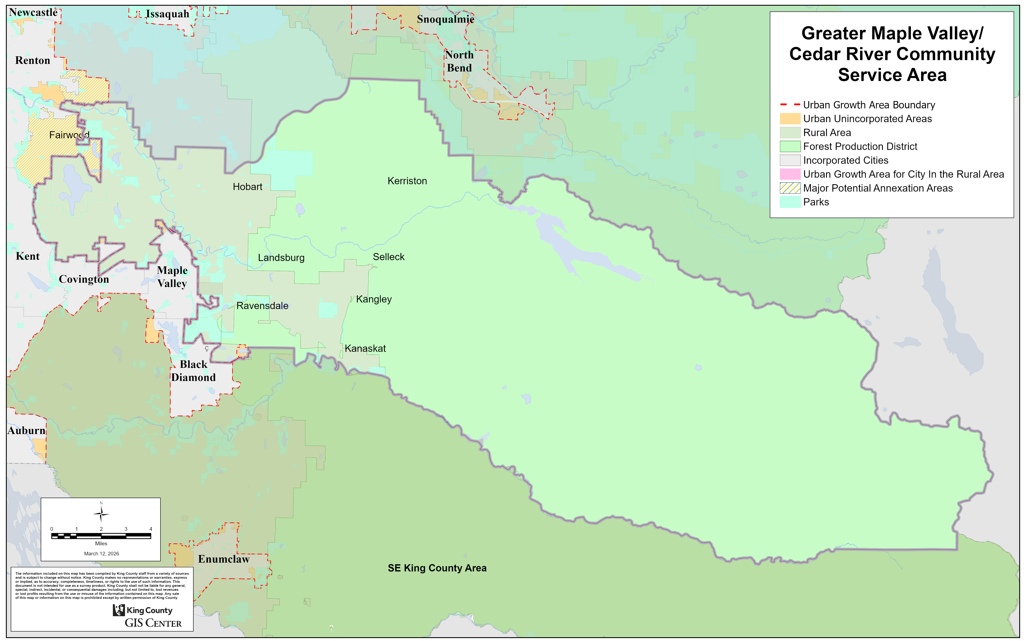
In many maps, the western part of the subarea is shown at a more detailed scale, while the entire subarea is shown as an inset, as illustrated below. The eastern portion of the subarea consists primarily of designated natural resource lands, including forests, rivers, and other open spaces. Most of these lands are publicly owned and addressed through King County Comprehensive Plan policies, and they play an important role in environmental and natural resource protection.
The more detailed scale used in some maps focuses on the westernmost 34 square miles of the subarea, where most of the area’s approximately 19,000 residents live. By focusing on where people live, work, and interact daily, these maps help communicate information about land use, transportation, community development, and public services, while still acknowledging the surrounding natural resource lands that comprise the majority of the subarea.
Figure 5 Western Portion of the Greater Maple Valley/Cedar River Subarea
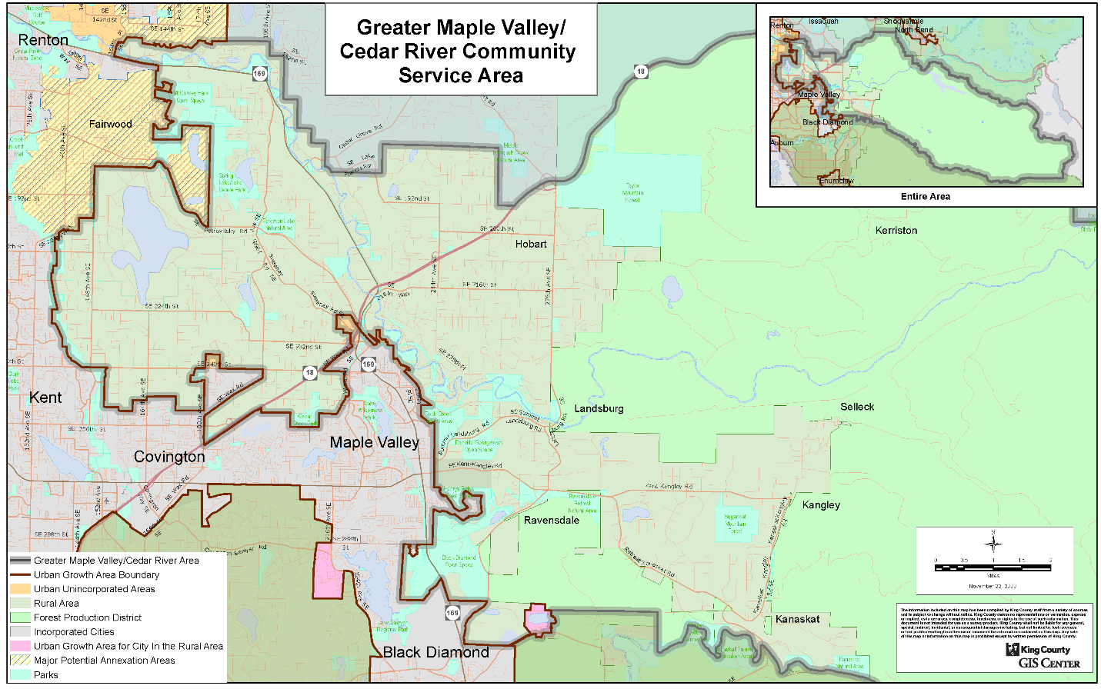

Important Notes about Subarea Terminology and Maps
Unless otherwise noted, data in this document refer to the entire CSA subarea, as shown in Figure 4. The terms “subarea,” “area,” and “CSA” may be used interchangeably. All maps in the following chapters are also provided in a larger format in Appendix A for easier viewing.

Tribal History
The Greater Maple Valley/Cedar River subarea is located within the Tribal Ceded Areas as defined by the Treaty of Point Elliott of 1855. The subarea includes lands of several Indian Tribes that have strong historic and contemporary connection to the area. The subarea is within the Tribes’ adjudicated Usual and Accustomed (U&A) fishing, hunting, and gathering area. The U&A harvest area is a historical region in which fish, shellfish, and other natural resources are collected. Tribal members exercise their treaty-protected harvest rights within their Tribe’s U&A fishing, hunting, and gathering area. In addition, Indian Tribes are considered co-managers of fisheries with the State and Federal government.

History of Industrial/Coal Mining to Present

The development and growth of this subarea was driven by two resource-based industries – logging/sawmilling and coal mining. The eastern almost 90% of the Subarea had been managed for timber production, and since 1900, has primarily been owned by the cities of Seattle and Tacoma and managed for their public water supply. Commercial timber production has largely ceased in Seattle’s xxx,xxx-acre Cedar River Watershed; while only about xx% of Tacoma’s Green River Watershed falling within the subarea is still managed for timber production – subject to the overriding water supply use.

The westernmost 34 square miles of the subarea were also heavily used for commercial timber production and sawmilling, particularly since the 1880s when steam-powered railroads and logging equipment enabled logging in the much of this area. Major early sawmilling operations within the subarea were located in the Selleck, Barneston, and Hobart areas. While the forest products industry was an economic mainstay throughout much of the subarea’s early history, sawmilling within King County has declined substantially in recent decades. The logging industry also experienced significant declines, particularly, as most public owners shifted focus toward providing environmental services (e.g., habitat, recreation, air and water quality, stormwater control, soil stability, scenic and spiritual amenities, carbon sequestration, climate change amelioration, etc.) rather than commercial timber production; while many of the larger industry owners closed their wood products mills and divested large portions of their former commercial timberland to low-density residential and other uses in the early 2000s.

But while logging and sawmilling was a major activity within this subarea well into the 1980s and 1990s, it was the discovery of very high-quality coal in the 1880s that really led to the development of most of the 34 square miles of the GMV/CR subarea lowlands. But to commercially mine this resource required railroads – both to supply the massive coal mining equipment, and to deliver the mined coal to market – primarily Seattle for both domestic use and export. The Columbia and Puget Sound (C&PS) railway was extended from Newcastle to Black Diamond and Franklin in 1884/1885, allowing development of the Cedar Mountain mine, and the major Black Diamond and Franklin mines in the southwest of the subarea. The Northern Pacific’s completion of the Cascade Branch in 1888 over Stampede Pass and down the Green River to Palmer, then into Tacoma via Enumclaw and Puyallup, allowed smaller mines at the foot of the Cascades (Kangley, Durham, Kanaskat, Bayne), to be developed. And the Northern Pacific’s completion of the Palmer Cut-off connecting Palmer directly with Auburn through Ravensdale and Covington in 1900 would allow the major Ravensdale mines to open.

The C&PS also boosted the development of Maple Valley in 1884, which would soon become a major railroad hub – also hosting the Northern Pacific starting in 1900, and the Milwaukee Road in 1907.

Coal production from King County peaked at about 1.2 million tons per year in the 1905 – 1920 period, then declined rapidly with the substitution of oil and hydroelectric power for coal; to where King County coal production by the mid-1950s was only about 150,000 tons – about the same as it was in the 1880s. And the last underground coal mine in the State, Palmer Coking Coal Company’s Rogers #3 Mine just west of Ravensdale, closed on December 17, 1975.

With the closing of the sawmills and coal mines within this subarea, many of the small, rural towns that supported these once-vibrant communities have disappeared. But a few were able to diversify, and have survived. The last passenger train stopped in Ravensdale in April 1960; the last train left Black Diamond in April 1969; and Maple Valley in 1990.

There remains an extensive (~xx%) forest cover on the 28,382-acres of Rural-zoned lands in the subarea, which contributes dramatically to its “rural” character. Some commercial timber production still occurs in the 34 square miles of lowland area managed by industrial, County, and State entities, as well as private residential owners. And some commercial harvest still continues in the subarea’s west-slope Cascade resource lands of the Green River watershed. But the bulk of the Forest Resource lands, as well as the majority of the rural-residential forest lands, are increasingly managed for their environmental benefits and services, rather than for commercial timber production.

Historic Hobart
Hobart was named after Vice President Garrett Augustus Hobart in 1903, when the Post Office was established. The early history of this area was with timber/lumber and farming/agriculture, dating from the 1880’s. The Peacock home was constructed in 1887 (2 years before statehood) and is still lived in by the family today.

The Wood and Iverson Mill, which operated from 1909-1939, was the largest lumber mill on the west coast for a time. Several company homes remain along 276th Ave SE and are over 100 years old. The Company even constructed "wooden stays" to transport drinking water from the Cedar River at Landsburg to Lake Youngs, and then to Seattle.

All of the lumber mills have passed into history along with the Hobart School and Gymnasium and the Hobart Dump. The identity of Hobart now is the Hobart Church which has the Hobart School bell since 1959. The Hobart Post Office, the Hobart Food Market and Fuel Station (1946) remain on the old Wood Iverson Company store site.

The rural lifestyle history remains consisting of farming and agriculture, with horses, cattle, sheep, pigs and chickens along with newcomers of llamas and alpacas. These all co-exist with the deer, elk, coyotes, cougars, eagles, bears and humans. Hobart residents want to preserve this lifestyle choice and to keep the Rural Area rural.

History of Local Organizations
The Greater Maple Valley Unincorporated Area Council (GMVUAC), founded in 1978 as the “Maple Valley Area Council” (~20 years before the incorporation of the City of Maple Valley), is a community council of volunteer citizens who reside in the unincorporated portion (i.e., outside the City of Maple Valley) of Tahoma School District # 409. The GMVUAC represents and advocates with King County, state officials, and other organizations for the interests of the citizens of its unincorporated area. GMVUAC covers an area defined by the Tahoma School District No. 409, excluding any portions, which are or become incorporated.

King County is the only local government that serves citizens living in unincorporated areas — those areas not included in cities such as Maple Valley or Black Diamond. Therefore, much of the GMVUAC’s efforts focus on ensuring the County maintains its promise of limited growth in the zoned “Rural Area” (RA) where most of the Subarea’s residents live. Most want to continue to see the trees, small farms and animals, lack of street life, and limited traffic that we have lived with for years. Therefore, the GMVUAC examines in detail every proposed policy issue affecting the rural area with the intent of ensuring that residents’ interests are represented in every venue that seeks to influence rural policies.

The purposes of the GMVUAC are:
1. To contribute to the orderly development of greater Maple Valley, while maintaining the historic rural character;
2. To make and publish studies which promote and improve the community; and
3. To act as liaison for the community in providing area representation, comments and recommendations to county, state, and federal agencies.

UACs And Evolution Of The Unincorporated KC CSA Program
Unincorporated Area Councils (UACs), such as the GMVUAC, have a long and beneficial history in serving as a community forum and voice for area residents regarding their concerns and issues with respect to King County governance, and how local and State policies and programs affect our rural area and its environs. On August 14, 1995, the King County Council (KCC) passed Motion #9643 that implemented the Citizen Participation Initiative (CPI) established by the KC Executive in EO PRE 7-1. KCC Motion #9643 Under this Motion and the CPI, it became the official policy of King County to acknowledge, recognize, and cooperatively work with UACs that met certain criteria. On May 28, 1996, the KCC passed Motion #9860 that formally accepted the Greater Maple Valley Area Council (now GMVUAC) as an official UAC. KCC Motion #9860 However, in 2012 the KCC enacted a modified approach to community involvement that focused its resources on large and all-encompassing Unincorporated Community Service Areas (CSAs), but still with great reliance on the continuation of individual UACs as a strong advocate in each of these newly designated and larger County service areas. In support of the 2012 legislation, KCC staff prepared a very comprehensive background report that may be read here: Revised Staff Report 2012-0267 0268 0374 Community Service Areas. The actual County Motion #13732 that passed enacting the now operative Unincorporated King County Community Service Area Program may be read here: KC Motion 13732 re UCSA and UAC Revision. The Unincorporated King County Community Service Area map may be viewed here: Unincorporated King County Community Service Areas_08 25 2016.

In 1994, King County adopted the urban growth area boundary to limit urban sprawl, coordinate services and growth in urban areas, and protect rural areas. Soon after, in 1997, the cities of Maple Valley and Covington were incorporated. The residents of rural Greater Maple Valley travel to these communities for services, shopping, school, and employment.
Today, the subarea lies almost entirely outside the urban growth area and consists primarily of forestry and rural lands, including open spaces. Natural resource extraction and timber harvesting continue to influence the local economy and shape the landscape. The area contains a limited number of local-serving retail establishments and its 19,000 residents enjoy the rural lifestyle associated with homes on low-density parcels from 2 to 5 acres, as well as many small farms of 10 to 80 acres.

Population Overview
Figure 6 Subarea Demographics
GMV/CR Subarea King County
Total Population 18,922 2,225,500
Socioeconomics
Average household size 2.94 2.9
Median age 44 37
Youths (under 18) 22% 19%
Seniors (over 65) 17% 14%
Persons with disabilities 9% 10%
Limited English-speaking 6% 11%
Housing
Owner-occupied households 90% 55%
Renter-occupied households 10% 45%
Rent-burdened households 33% 41%
Ownership-burdened households 25% 24%
Income and Poverty
Median household income $144,800 $124,800
Households below poverty line 4% 8%
Race and Ethnicity
White 70% 53%
Black or African American 3% 6%
American Indian and Alaska Native 1% <1%
Asian 10% 21%
Native Hawaiian and Other Pacific Islander <1% 1%
Some other race <1% 1%
Two or more races 8% 7%
Hispanic or Latino 9% 11%
Black, Indigenous, People of Color (BIPOC)¹ 30% 47%
BIPOC population is calculated by subtracting White non-Hispanic/Latino population from the total population.
Sources: 2020 Census. 2024 American Community Survey (ACS) data. Figures rounded to an appropriate significant digit.
The Greater Maple Valley/Cedar River subarea has approximately 19,000 residents. The subarea has an older population than King County, with a median age of 44 compared to 37, and a slightly higher share of seniors over 65 (17% vs. 14%).
Compared to King County, average household size is larger (2.94 vs. 2.49), and the proportion of residents with limited English proficiency is lower (6% vs. 11%).
Homeownership is higher in the subarea (90% vs. 55%), while renter households are fewer (10% vs. 45%).
Rent-burdened households are lower (33% vs. 41%), and ownership-burdened households are approximately the same (25% vs. 24%).
The subarea is less racially and ethnically diverse than King County as a whole. White residents make up 70% of the population compared to 53% countywide, Asian residents 10% vs. 21%, and Black or African American residents 3% vs. 6%. Hispanic or Latino residents are 9% compared to 11%, and overall BIPOC residents are 30% vs.47%. Slightly higher median income and slightly lower poverty rates.

Community Areas
Community members recognize several informal neighborhood areas within the subarea, as depicted by Figure 7. The neighborhood boundaries roughly correspond to the Tahoma School District Board Districts map.
Figure 7 Map of Community Areas
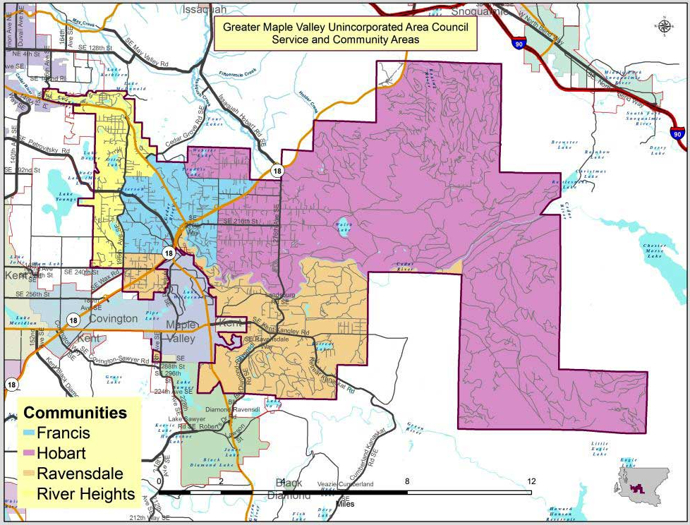

Treaty of Point Elliott, 1855, Governor’s Office of Indian Affairs, State of Washington [LINK]
For a map providing an interpretation of Tribal ceded areas, see Tribal Ceded Areas in Washington State. Washington Department of Fish and Wildlife, Apr. 2017 [LINK]
Greater Maple Valley Unincorporated Area Council. (2017). GMV service area map [LINK]
Tahoma School District. (2022, August). Tahoma School District board director districtshttps://cdnsm5-ss19.sharpschool.com/UserFiles/Servers/Server_168561/Image/082022 TSD Board Director Districts.pdf [LINK]

