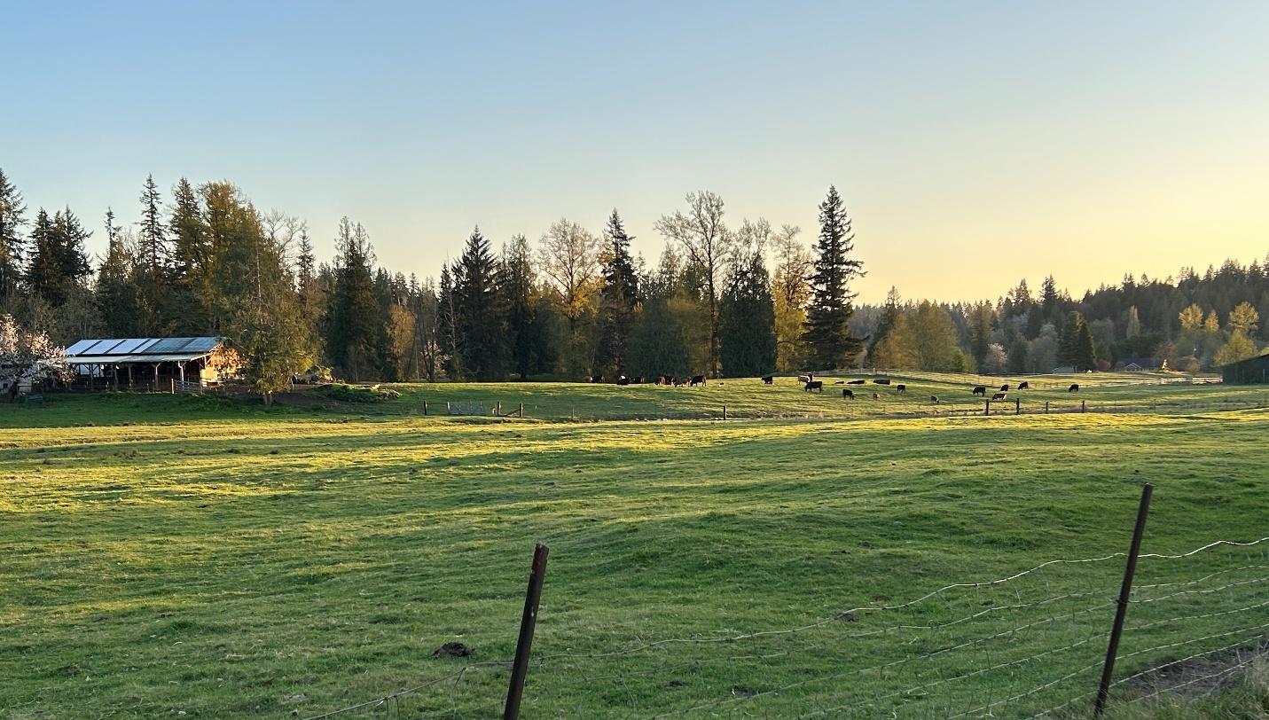

Chapter 4: Land Use
The King County Comprehensive Plan assigns land use designations to all unincorporated areas of the county to guide the long-term intended use of the land. Zoning classifications are then applied to individual parcels to specify permitted uses and to establish the development standards used in reviewing land use and building permit applications.
Within the subarea, the Comprehensive Plan primarily designates land as Rural Area, Natural Resource Lands including forestry and mining, and Rural Neighborhood Commercial Centers. These designations reflect the Plan’s goal of preserving rural King County by maintaining diverse landscapes, supporting vibrant rural communities, and fostering sustainable rural economic opportunities for residents. The subarea also includes Parks and Open Space.
The Greater Maple Valley/Cedar River Community Service Area (CSA) lies primarily outside the Urban Growth Area (UGA), with only a small portion within the UGA near the City of Black Diamond. Over half of the CSA is composed of designated resource lands, most of which are publicly owned. These lands are governed by policies in the King County Comprehensive Plan.
As a result, the Greater Maple Valley/Cedar River Subarea Plan focuses on the westernmost 34 square miles (10% of the total subarea)—home to most of the area’s 19,000 residents. Within this planning subarea, housing typically consists of single detached homes on large lots, most with significant forest coverage remaining on the non-residential portion of the parcel. The area also includes several small retail stores in designated commercial zones, mineral resource operations, and small-scale agricultural uses.
The Growth Management Act and the Comprehensive Plan recognize the differences in landscape, infrastructure, and service levels between urban and rural communities. King County remains committed to preserving rural character and supporting small rural economic clusters.

Land Use and Zoning

Land Use Designations
The entire Greater Maple Valley/Cedar River subarea includes several land use designations over 220,802 acres of land. Additional detailed maps about certain land uses are in Appendix A.

Comprehensive Plan Land Use Designation | Acres
Forestry | 183,022
Rural Area | 28,382
King County Open Space System | 4,914
Mining | 1,907
Urban Growth Area for Cities in the Rural Area | 134
Industrial | 26
Rural Neighborhood Commercial Center | 23
Agriculture | 15

Figure 8 Map of Land Uses in Greater Maple Valley/Cedar River

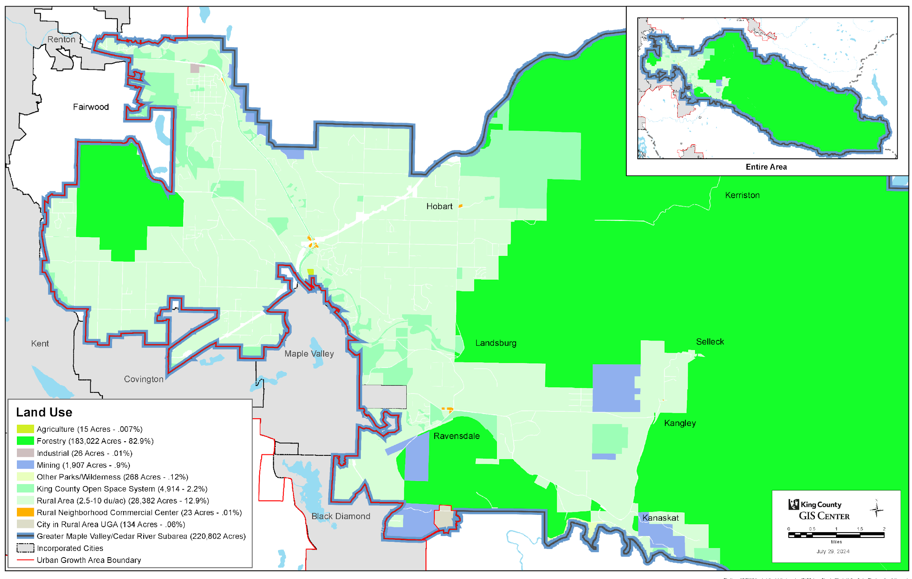

Forestry
Approximately 183,022 acres—about 83 percent of the subarea—are designated within the Forestry land use designation, which includes a mix of public and private land ownership. The eastern portion of the subarea is predominantly designated as Forestry and is largely publicly owned, managed by entities such as the City of Seattle, the Washington State Department of Natural Resources, and the U.S. Department of Agriculture. In addition to these public holdings, parts of the Forestry designated lands are owned by private industrial forestry companies. Notably, BTG Pactual – Timberlands Investment Group and Weyerhaeuser are two major private landowners operating commercial forestry activities in the subarea.
Key working forest lands within the subarea include Taylor Mountain Forest, Sugarloaf Mountain Forest, and portions of the Tomanamus Forest, owned by the Muckleshoot Indian Tribe. Taylor Mountain Forest, managed by King County, covers 1,924 acres in an area northeast of Hobart, and is certified as a working forest by the Forest Stewardship Council. Sugarloaf Mountain Forest, also managed by King County, spans 285 acres and is located off SE Kent-Kangley Road in the Ravensdale/Kangley area, in the southwestern portion of the subarea.

Rural Area
The Rural Area (ra) designation is the second largest land use designation within the subarea with 28,382 acres, which is 12.9 percent. It is characterized by low-density residential development, farms, ranches, forests, watersheds crucial for both fisheries and flood hazard management, mining areas, unincorporated towns, historic sites and buildings, archaeological sites, and regionally important recreation areas.

The County has designated a Cedar River/Ravensdale Rural Forest Focus Area (RFFA) to identify Rural Area lands where the small, private residential owners would be encouraged to retain and sustainably manage a significant portion of the existing forests on their property.

King County Open Space System
The King County Open Space System (os) land use designation includes regional parks and recreation amenities, natural areas, forests, regional and back country trails, and local parks in unincorporated areas. The system provides benefits to county residents including recreation, conservation of natural and working lands, flood hazard management, wildlife habitat, and connection of critical areas. Within this designation, there are 4,914 acres (2.2 percent of the subarea).

Mining
The subarea has 1,907 acres designated for mining, including 14 mineral resource sites designated by the Comprehensive Plan, which include nine designated sites and five potential sites. Additionally, 10 sites are located outside and adjacent to the subarea. Several of these sites are located on the border of the subarea, underscoring their significance to both the immediate area and neighboring jurisdictions. Find a map of mine sites in Appendix A.

Potential Annexation Area
Washington’s Growth Management Act identifies cities as the most appropriate local governments to provide urban services. The Comprehensive Plan, as well as the King County Countywide Planning Policies, encourage the annexation of unincorporated lands that are already urbanized. Greater Maple Valley/Cedar River subarea has one annexable area reserved for the cities in the Rural Area, called a Potential Annexation Area (PAA).
Potential Annexation Areas (PAAs) are located within the Urban Growth Area. King County serves both as the regional government—collaborating with cities to facilitate eventual annexation of PAAs—and as the local government, providing essential programs and services to residents in such urban unincorporated areas until annexation occurs.
Lake Twelve is the only PAA in the subarea and is adjacent to the City of Black Diamond. The PAA is 97 acres with approximately 100 residents. This urban unincorporated area is zoned Urban Reserve (UR), meaning that until annexation occurs the maximum density allowed is one residential home per five acres. The density to which these lands will be zoned after annexation is dependent on the future decisions of Black Diamond. There is no established timeline for annexation of this area. A map of Lake Twelve PAA is found in Appendix A.

Rural Neighborhood Commercial Centers
The subarea features five Rural Neighborhood Commercial Centers (RNCCs). King County identifies RNCCs through the Comprehensive Plan. These centers are small-scale commercial areas located within rural parts of the county, and they are designed to provide essential goods and services to local rural residents without encouraging urban levels of development. The Comprehensive Plan states that no new RNCCs are needed, but existing centers may be enhanced and maintained.
Figure 9 Map of Rural Neighborhood Commercial Centers in Greater Maple Valley/Cedar River
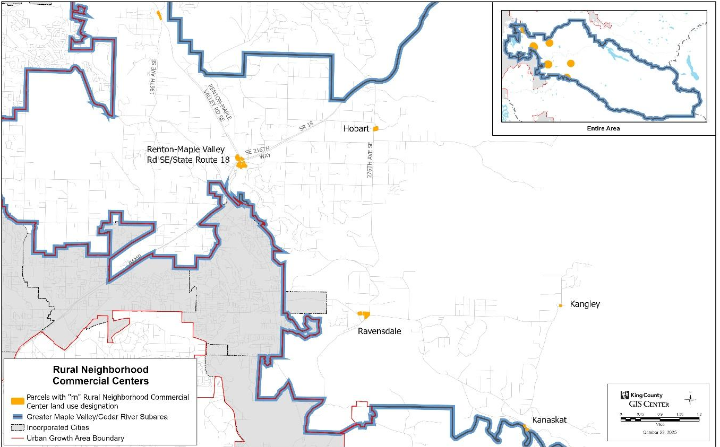
The Renton-Maple Valley Road SE/State Route 18 RNCC is the subarea’s largest RNCC at 10.5 acres. Within its boundaries, the center includes a gas station, a coffee stand, a grocery store, and various office buildings.
The Ravensdale RNCC spans 7.2 acres and includes a mix of businesses, such as a convenience store, storage and warehouse facilities, a hair salon, general office spaces, and single detached homes. Additionally, there are three vacant parcels within the center. As one of only two RNCCs in the subarea with available vacant parcels, the Ravensdale RNCC presents economic opportunities for development consistent with the permitted uses in the Neighborhood Business (NB) zone, development standards in the King County Code, and the policies of the Comprehensive Plan.
The Hobart RNCC encompasses approximately 2.9 acres and includes the Hobart Market, which features a small grocery store, post office, and gas station. Like Ravensdale, the Hobart RNCC contains vacant parcels that present opportunities for future economic development.
The Kanasket RNCC is 0.7 acres along the Green River. Although there is no commercial activity at present, past uses have included a bike and kayak rental facility and a tavern. Existing buildings from these uses remain and are unoccupied.
The Kangley RNCC is the smallest RNCC within the subarea, consisting of a single parcel totaling 0.4 acres. The site currently contains an existing single detached residence.

An additional two lots in the subarea are designated RN, but not within a designated RNCC. Located at the intersection of Renton-Maple Valley Road and 196th Avenue SE, the lots together total 1.51 acres.

Zoning Classifications
The King County Zoning Code (KCC Title 21A) establishes rules for each zoning classification, including permitted activities and development standards for residential, commercial, and industrially zoned lands. Some land is not assigned to a zone, including some rights-of-ways and waterways. For that reason, the total number of acres reported for land use designations and zoning classifications may not correspond.
The following map depicts zoning in the subarea.
Figure 10 Map of Zoning Greater Maple Valley/Cedar River subarea
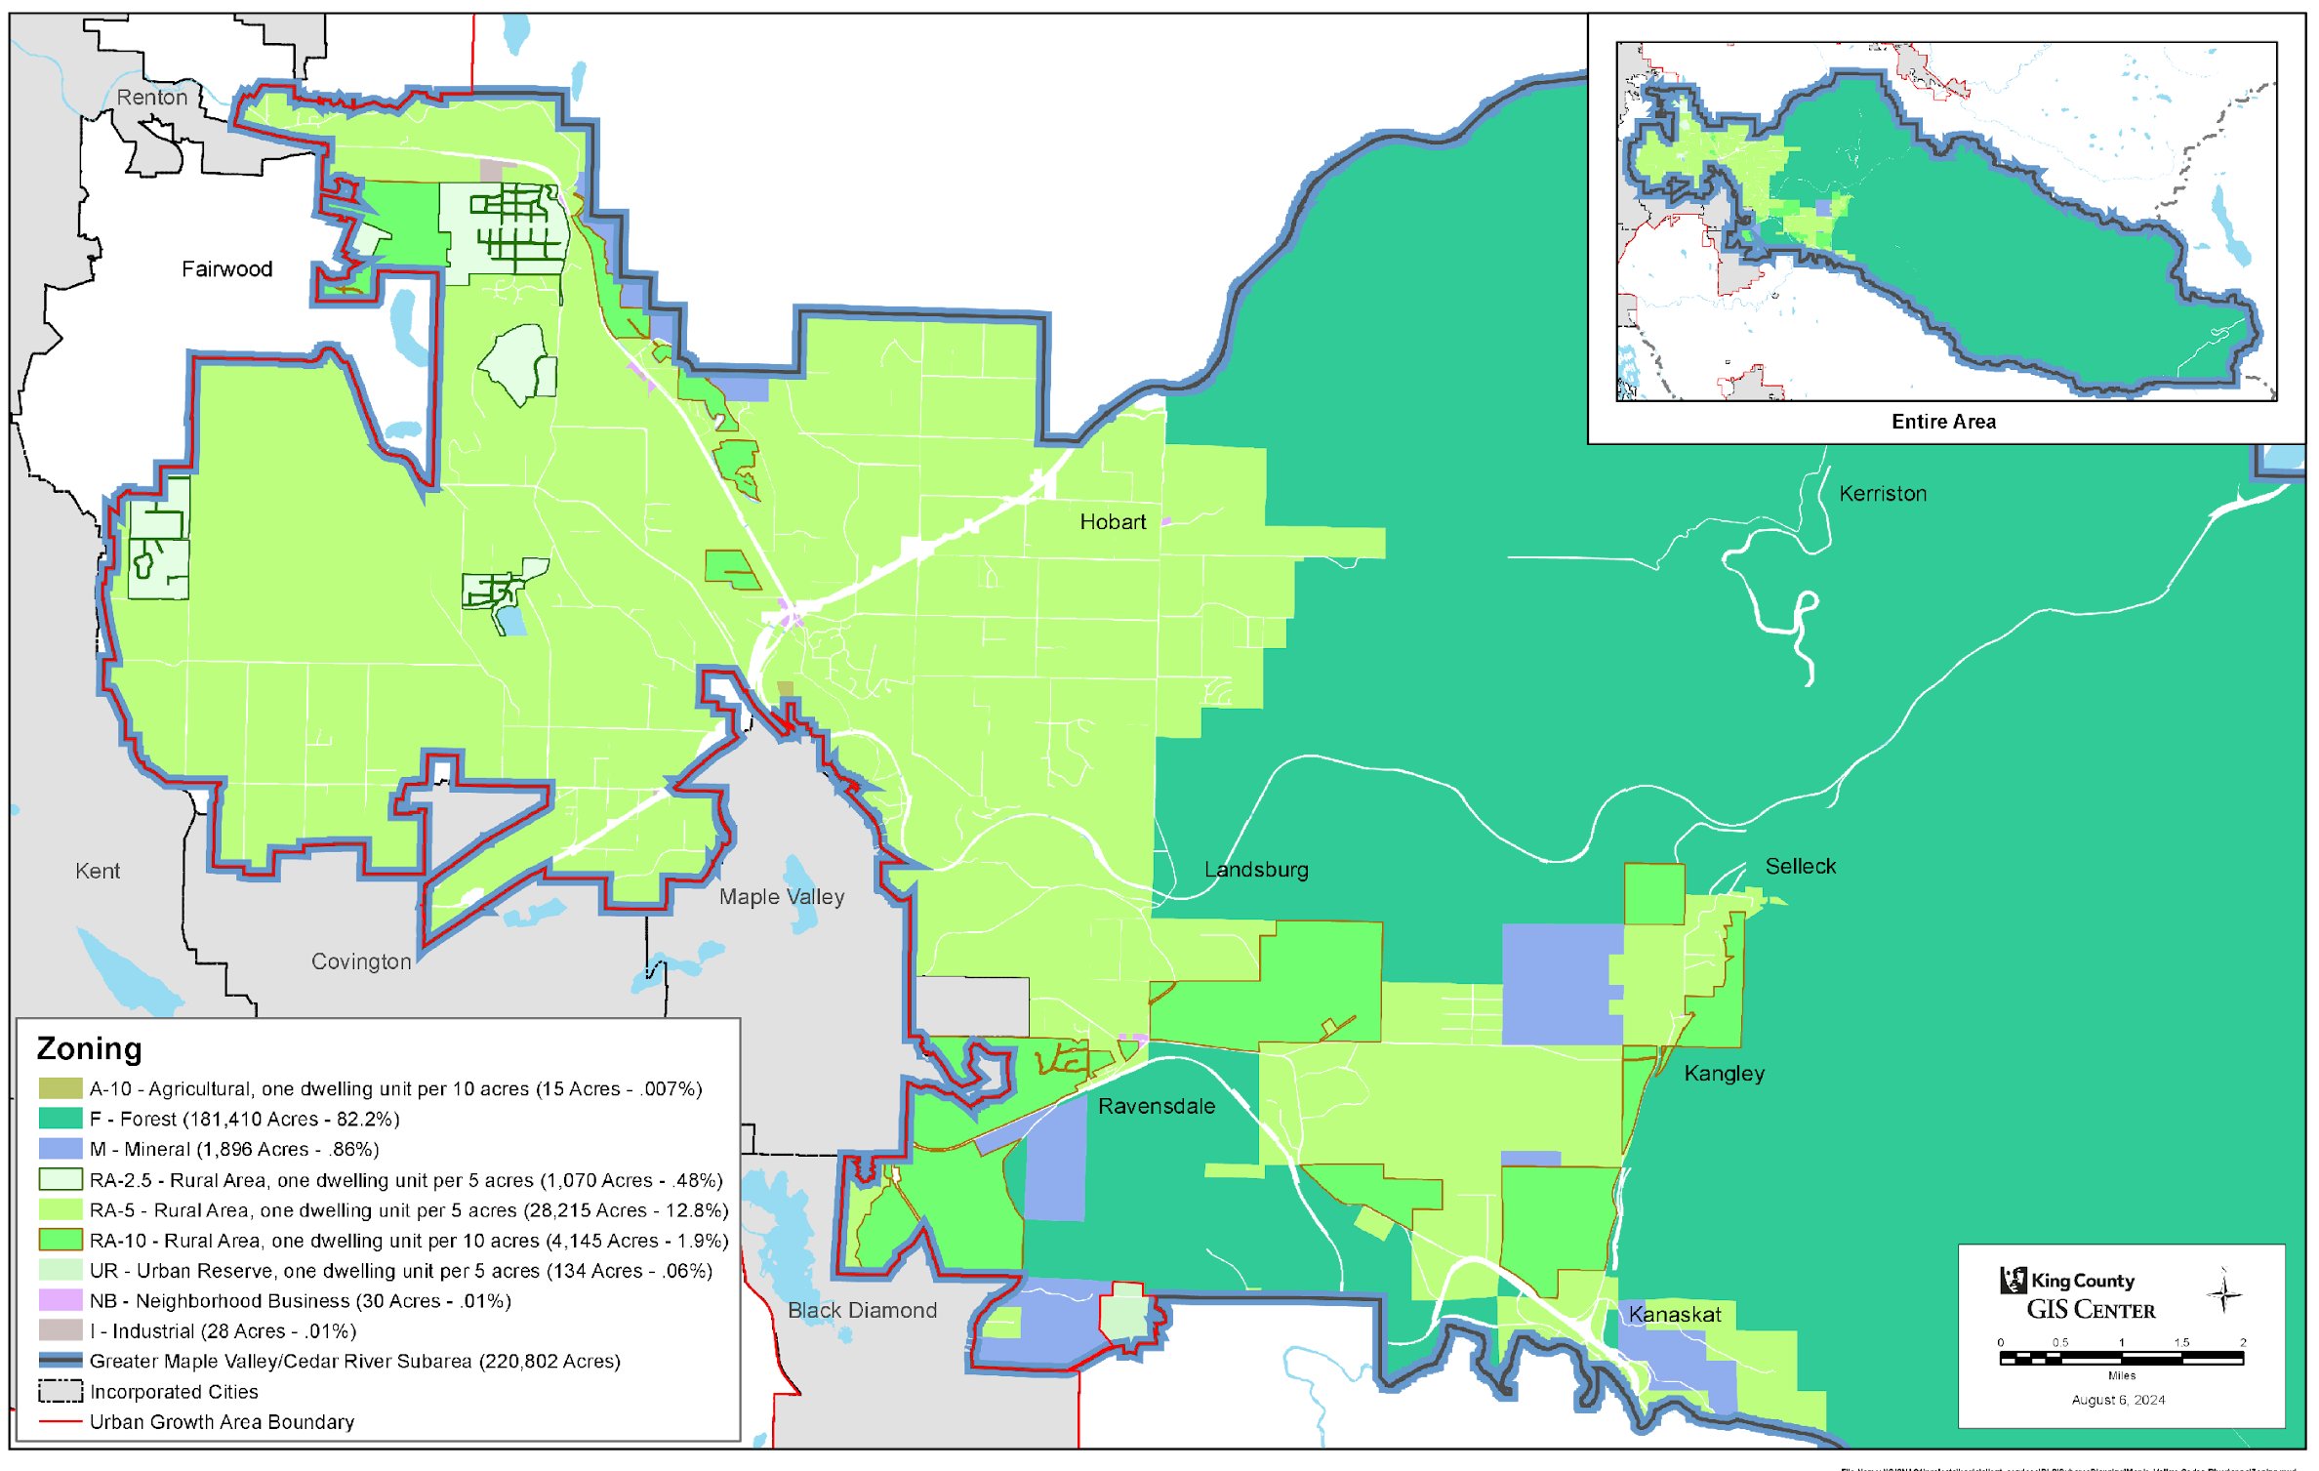
Forest Zone: The predominant zoning classification in the subarea is Forest (F), which is 82 percent of the total area. This zone is intended to preserve and protect forest lands by supporting sustainable timber production, limiting incompatible uses, and allowing compatible recreation and conservation activities. Besides sustainably producing timber for the production of wood and paper products by a viable, local forest products industry, these forests also produce a host of ‘environmental services’, including habitat, recreation, air and water quality, stormwater control, soil stability, scenic and spiritual amenities, carbon sequestration, climate change amelioration, etc. In many cases, these auxiliary ‘products’ may well be even more important than the traditional logs and chips.
Rural Area Zone: The second most predominant zoning classification is Rural Area (RA). The RA zone allows low-density residential development along with small-scale farming, forestry, recreation, and other rural-compatible uses, while limiting development intensity to protect rural character and reduce conflicts with nearby resource lands.
- RA-10 (Rural Area, one dwelling unit per 10 acres) represents 2 percent of the subarea and xx% of the Rural Area Zone of the subarea.
- RA-5 (Rural Area, one dwelling unit per 5 acres) is 13 percent of the subarea and yy% of the Rural Area Zone of the subarea.
- RA-2.5 is a small amount of RA-zoned land. This zone occurs where the predominant lot pattern is below five acres in size for lots established prior to the adoption of the 1994 Comprehensive Plan.

There is also a special classification within the Rural Area Zone, known as a Rural Forest Focus Area (RFFA). On RA-zoned lands falling within an RFFA, the County will apply “special efforts”, including applying “target funding, when available, new economic incentive programs, regulatory actions, and additional technical assistance” to encourage the small, private residential landowner to “maintain forest cover” on their property through “the practice of sustainable forestry.” These small private forests would thus augment the extensive forests on the Forest-zoned lands within the Forest Production District (FPD). Within the GMV-CR subarea, the Cedar River/Ravensdale Rural Forest Focus Area lies south of the Cedar River, contiguous with the FPD, and covers xx,xxx acres (xx% of the 33,430 acres of Rural Area Zone lands in the subarea). The combination of the large, public/industrial-owned forests of the FPD, with the small, private residentially-owned forests of the Cedar River/Ravensdale RFFA provides a healthy forest resource supporting the production of forest products as well as critical ‘environmental services’.
Mineral Zone: The subarea has historical and present use of mining activity, with 0.86 percent of its zoning classified as Mineral (M). This zone is intended to support environmentally responsible extraction and processing of mineral and soil resources by protecting known deposits while limiting incompatible development and impacts to neighbors. Reclamation is required to restore the land per KC Code Title 21A.22.081 Reclamation and, in the Forest zone, with the ultimate aim to create a mature forest with a healthy mix of resilient native plants.
Neighborhood Business Zone: The Neighborhood Business (NB) zone in the subarea covers 30 acres, or 0.01 percent of the total area, and is the only zone specifically dedicated to commercial uses. The NB zone allows small-scale retail, services, and limited housing that serve nearby neighborhoods.
Industrial Zone: The Industrial (I) zone comprises a small portion of the zoning in the subarea, covering only 28 acres, or 0.1 percent of the total area. However, there are industrial uses present in other zones that were either conditionally approved or are considered legal non-conforming. The Industrial (I) zone allows manufacturing, processing, warehousing, and other industrial activities, while limiting non-industrial uses to those that support industrial operations.
Agricultural Zone: The agriculture zone comprises only 15 acres in the subarea, or 0.01 percent of land area. The Agricultural (A) zone allows farming and agricultural production, related uses, and limited residential development that supports farm operations.
Urban Growth Area for Cities in the Rural Area: The Lake Twelve Area is identified as a Potential Annexation Area for Black Diamond. This area is 134 acres in size, or .06 percent of the subarea.

Planning for Future Growth
Apart from the unincorporated Urban Growth Area, minimal future growth is planned for the subarea. The 2021 King County Countywide Planning Policies do not assign housing and jobs growth targets to rural unincorporated King County. The 2019-2044 housing and job targets for the Cities in the Rural Area include the urban unincorporated Potential Annexation Areas for each city. A portion of the Black Diamond Potential Annexation Area (PAA), Lake Twelve, is located within the subarea. While the Black Diamond PAA has a housing growth target of 328, the Lake Twelve portion of the PAA has limited capacity to accommodate urban growth.
To preserve rural character, no required levels of future housing or job growth have been established for the subarea. However, development may occur consistent with adopted zoning.
The County acknowledges that future growth—including jobs, housing, and other services—will occur on lands that are invested in and managed by federally recognized Indian Tribes. Coordination with the Tribes is ongoing as part of the planning process.

Community Priorities
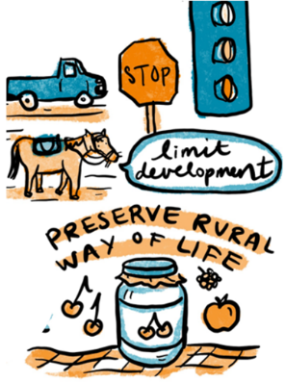
During the engagement process, consistent themes emerged reflecting the community's vision for the subarea's future, including preferences for land use, character, and the overall aesthetic of the landscape over the next 20 years. Following are important priorities we heard for the Greater Maple Valley/Cedar River subarea:
Image SEQ Image \* ARABIC 12 Graphic depicting community feedback by artist Natalie Dupille
- Keep the rural area rural. Throughout the public engagement process, community members emphasized the importance of preserving the subarea's rural character and limiting residential and commercial growth. Retention of forests and wildlife habitat are critical components of this rural character. They were also particularly concerned about development that could increase transportation impacts on rural roads, contribute to noise or air quality issues, or create code enforcement challenges.
- Support for existing low-density residential. Consistent with the Comprehensive Plan, community members expressed support for maintaining low-density housing while restricting zoning that would allow for the development of duplexes and triplexes. However, rural accessory dwelling units (ADUs) were generally supported under certain circumstances. Residents viewed ADUs as a way to support multigenerational living, offer more flexible housing options, and create opportunities for extra income—all without significantly changing the character of the community.
- Protect our healthy forests. Besides providing wood and paper products, the extensive “environmental services” provided by these forests are critical to our lifestyle. Retention of the Forest Production District and the Cedar River/Ravensdale Rural Forest Focus Area, and continuation of programs like Designated Forestlands, Transfer of Development Rights, and Conservation Easements are all important means to protect this most-critical resource.
- Concern about new and expanded industrial activities and uses. Community members expressed deep concern about certain new industrial projects and the expansion of existing industrial and mineral resource operations, citing traffic impacts, noise disturbances, and potential air and water quality impacts. Examples include operators who are essentially running large-scale landfilling operations in the name of “mine reclamation.”
- Maintain existing limits for commercial zoning. Community members generally expressed support for retaining the existing limits of the commercial zoning and keep RNCCs business only, not housing.
- KC Permitting practices for large-scale repeat offenders. The permitting process for large-scale, commercial operators who repeatedly violate Permit Conditions, or County Code/Policy, needs serious improvement. Examples include:
  - Renewal of permits that are not in compliance with permit terms, County code/policy, continuing need, or continued qualification of operator;
  - Public has no opportunity to comment on permit renewals;
  - Lack of regular monitoring, or any monitoring unless owner requests, or Permitting is presented with a formal complaint;
  - Lack of public transparency; failure to respond to public inquiries or complaints;
  - Ignoring (or dismissing?) public comments without any discussion or rebuttal;
  - Failure to issue penalties or mitigation for permit violations that would discourage repeat offenses; and
  - Issuance of a mining permit, without a detailed, milestone-driven, enforceable mine reclamation plan, including reclamation completion.
- Code enforcement needs. Community members expressed the need for stepped-up MONITORING and code enforcement for the following types of activities:
  - Activities that are not permitted under zoning; including properties where non-conforming uses have the potential to expand;
  - Properties that see an accumulation of junk vehicles and other debris;
  - Informal camping grounds;
  - Non-compliance with permit conditions for large-scale industrial owners; and
- Mine reclamation. Community members are concerned that some mine “reclamation” appears to be, and some cases is, perpetual landfilling operations.
- Potential growth of event venues. Community members suggest that it may be beneficial to examine the temporary use permit process and its requirements to ensure that special event activities do not result in traffic impacts, noise levels, and associated activities that are inconsistent with the rural character of the area. “Temporary” should mean “temporary” and not endless renewals.

Policies

GMVCR-1 Protect rural character by limiting property-specific development conditions that would increase residential densities or allow commercial activities incompatible with the rural uses.

GMVCR-2 Maintain or reduce residential densities near natural resource lands and the Forest Production District.

GMVCR-4a KC Permits will not be renewed until permit fees have been paid, and the project is in compliance with Permit Conditions, KC Code and KCCP Policy, and Subarea Guiding Principles.

GMVCR-4b Mining permits will not be issued without a detailed reclamation plan for the property, including permissible reclamation fill material, location, approximate volumes, and expected reclamation timing. Public should have opportunity to comment on these plans/permits, and any major changes. KC Permitting must retain a copy of these plans.

GMVCR-4c Clarify the definition of Forest Production District lands.

GMVCR-4d Pursue elimination of all Industrial Zones along the Cedar River by requiring redesignation of the Industrial Zones to underlying zoning, either upon sale of the properties or upon agreement of the property owners.

GMVCR-4e Prioritize protecting forest cover, working forests, salmon habitat and watershed health when siting mining and mineral and gravel extraction. Sites closest to watershed basin resources shall be considered lower priority for development.

GMVCR-4f Permit mineral extraction sites to size mines only as large as needed, as defined by readily available and reachable mineral resources, not necessarily using all the acreage available, or a full parcel’s acreage; Reclamation Plans shall be defined before development; and any subsequent changes to the permit or plan shall not delay reclamation by more than 25% of the period allowed on the original permit.

GMVCR-4g Prohibit any mineral extraction site from importing wood waste from land clearing (e.g., tree stumps, etc.), construction and demolition waste, or any toxic substances.

Tomanamus Forest, Muckleshoot Indian Tribe, official tribal website [LINK]
Revised Code of Washington Chapter 36.70A, section 110 [LINK]
2021 Adopted Countywide Planning Policies (kingcounty.gov) [LINK]
A Potential Annexation Area is an area in urban unincorporated King County that is affiliated with a particular city for future annexation.
A decrease to Black Diamond’s PAA target has been proposed by Growth Management Planning Council, and is being considered by the King County Council. [LINK]

