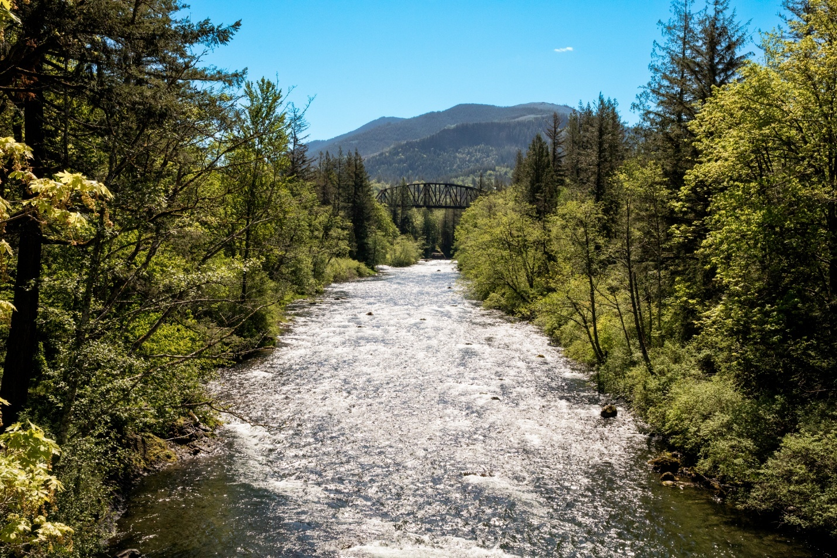

Chapter 6: Environment
The Environment chapter describes natural systems within the Greater Maple Valley/Cedar River subarea, and their interactions with human activities. The following pages describe programs and policies to protect natural systems, promote climate resilience, and ensure long-term sustainability, focusing on preserving water and air quality, conserving habitats, and adapting to environmental pressures like climate change and wildfire risk. Community priorities and policies presented in this plan support both ecological health and community well-being while helping maintain the area’s rural character.
The subarea encompasses a diverse landscape of rural lands and natural features, particularly forestlands, lakes and ponds, and riverine systems, spanning from the East Renton Highlands to the Cascade Mountain crest. The two major watersheds that transect this geography include the Cedar River and Green River watersheds.
Community members report that the natural environment is integral to the subarea’s identity and appeal. This unique area has a strong rural identity just 20 miles southeast of the urban city of Seattle offering many outdoor activities to the urban communities. Forested areas, which include the designated Forest Production District, play a crucial role in maintaining air quality, water filtration, and wildlife habitats, while also providing recreational spaces for residents and visitors. These lands are interspersed with rivers, wetlands, and lakes, which are vital for fish and wildlife, particularly salmon populations that depend on clean, cold water for their life cycle.
The subarea is bordered by and contains forests, agricultural lands including family owned and operated farms, and water bodies which collectively form a network of habitats that are connected to support regional biodiversity, recreational opportunities, and cultural heritage.

Forests
The subarea covers approximately 345 square miles, with about 83 percent—roughly 300 square miles—designated as Forest Production District. This area, extending from the Landsburg neighborhood to the Kittitas County border, is primarily composed of public and working forest lands, including Taylor Mountain Forest, Sugarloaf Mountain Forest, and portions of the Tomanamus Forest owned by the Muckleshoot Indian Tribe.
Taylor Mountain Forest, managed by King County, is a 1,924-acre, Forest Stewardship Council-certified working forest located between Hobart and North Bend. Also managed by King County, the 285-acre Sugarloaf Mountain Forest lies off SE Kent-Kangley Road in the Ravensdale/Kangley area. Recreational opportunities in both forests are described in Chapter 7: Parks, Open Spaces, and Cultural Resources.

Watersheds
Characteristically, the subarea is defined by the Cedar River-Lake Washington and the Duwamish-Green River watersheds, and also shares boundaries with the Sammamish River and the Snoqualmie River watersheds. With headwaters in the Cascade Range, the Cedar River is 45-miles long and flows in a westerly direction through the subarea, providing critical habitat for fish and wildlife, and drains into Lake Washington then through the Hiram Chittenden Locks, (which connect Lake Washington to the Puget Sound). Madsen, Taylor, and Rock creeks are notable tributaries to the Cedar River prior to flowing into Lake Washington (a well known and heavily used freshwater body of water for leisure activities, aquatic sports, fishing and sea plane travel).
Prior to white settler colonization, the Cedar River was historically a meandering, braided riverine system flowing into the Black River. Human intervention in the early 20th century diverted the Cedar River to flow into the Duwamish River and eventually into Lake Washington. The upper portion of the watershed is a protected area owned by the City of Seattle that provides hydroelectric power generation and drinking water to 1.4 million residents in Seattle. Along the Cedar River, the Chester Morse Lake functions as the water storage system behind the 1914 Masonry Dam. Lake Young, located between Renton and Maple Valley,plays a vital role in the Cedar River watershed system as a buffer to ensure adequate water supply to the residents of Seattle
The Duwamish-Green River watershed includes the 93-mile long Green River. The Green River originates in the Cascade Range and flows northwest, draining into the Elliot Bay via the Duwamish River. The Upper Green River forms a large portion of the southern boundary of the Greater Maple Valley/Cedar River subarea and receives several tributaries including Friday Creek, Sawmill Creek, Champion Creek, Smay Creek, and Charlie Creek. The Green River enters the earthen Howard Hanson Dam, constructed in 1961, and managed by the US Army Corps of Engineers, at river mile 68. The dam provides flood mitigation and control in the rainy season and is a water supply for Tacoma, Washington. The Duwamish-Green River is the longest river in King County.
Figure 14 Map of Watershed Boundaries
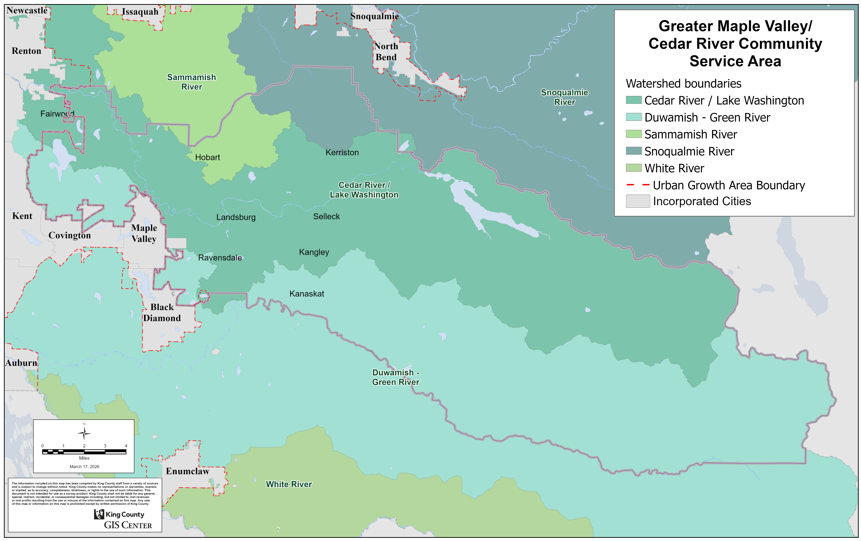

Habitat
The forested areas and watersheds provide integral habitat for fish and wildlife. Taylor Mountain Forest, largely composed of mature red alder trees, protects ecological systems and provides passive recreational opportunities and habitat wildlife network areas for species like black bear and cougar. The Cedar River supports populations of sockeye, coho, and Chinook salmon that access and spawn in the middle reaches of the river. Additionally, other species like the pygmy whitefish and isolated populations of bull trout are found in the Chester Morse Lake and upper reaches of the Cedar River. The Green River supports vital spawning and rearing habitat for Chinook, chum, and pink salmon species; fish passages programs have been installed to ensure passage of adult spawning salmon above the Howard Hanson Dam and the Landsburg Dam.
Figure 15 Map of Fish and Wildlife Habitat Conservation Areas

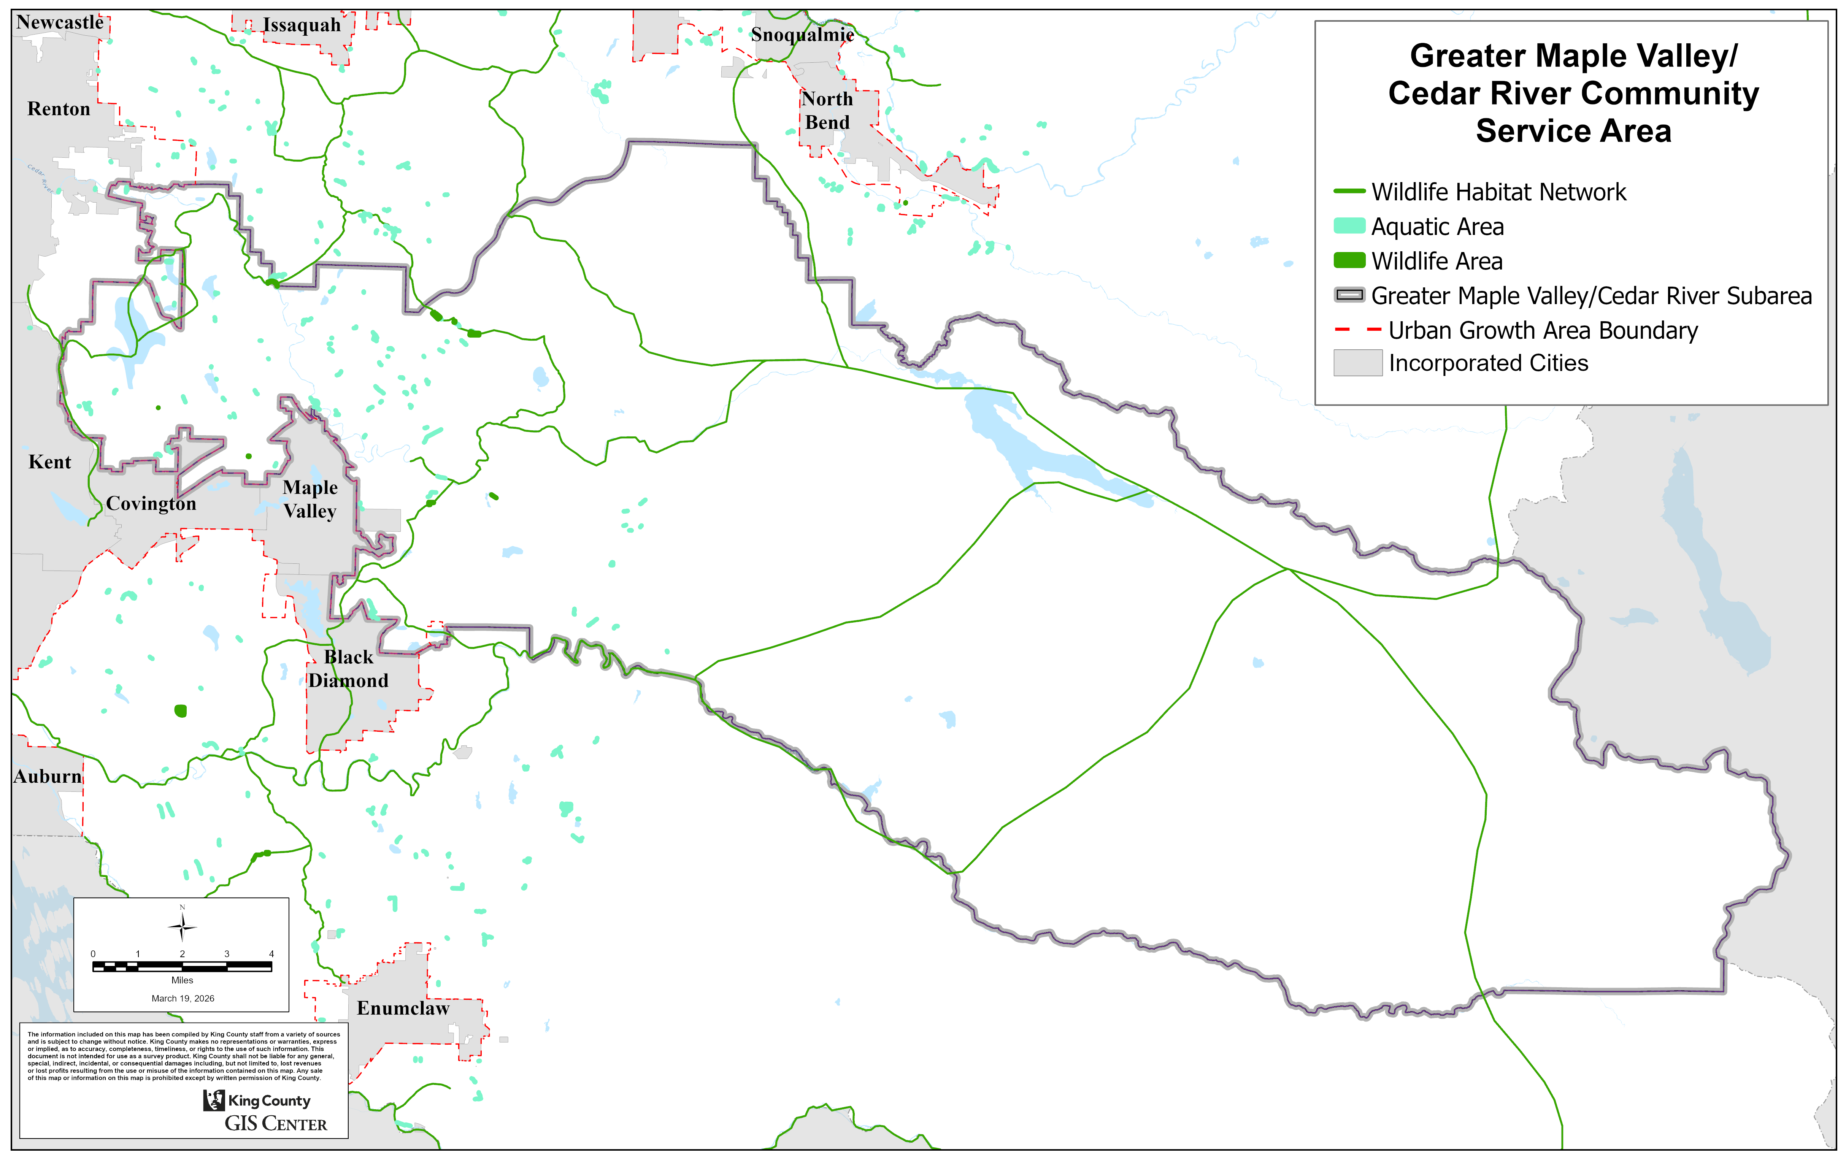

Flooding and Geologic Hazards

Flooding Hazards
Cedar River: Historically, flooding in the Cedar River watershed has been caused by heavy rainfall and warmer fall and winter seasons, which lead to rapid snowmelt and increased runoff. The most severe flooding events typically occur between October and March. The Cedar River experiences fast-moving, erosive flows, which make flooding events more sudden and intense compared to other rivers in the area.
In many sections of the Cedar River below the Landsburg Diversion Dam, flooding has regularly impacted rural areas, damaging properties and infrastructure. The river flows mainly through the Cedar River Valley, which naturally concentrates water flow. Over time, human alterations have narrowed the river's channel, leading to bank erosion and changes in the river's path, which causes sediment buildup. This reduces the river's capacity to carry water, lowers water quality, and increases the likelihood of flooding in smaller tributaries.
According to the King County Flood Management Plan, flooding on the Cedar River is considered a major hazard from Landsburg to the outlet at Lake Washington, with multiple areas experiencing repetitive flooding. Efforts to reduce flooding have focused on controlling bank erosion and stabilizing the river channel by installing structures to prevent the river from shifting.,
Green River: The segments of the Green River that pass through the subarea include the Upper and most of the Middle Green River. The Upper Green River runs from the Cascade Mountains to the Howard Hanson Dam, while the Middle Green River stretches from the Green River Gorge (at river mile 45) to Flaming Geyser State Park. These sections of the river are characterized by steep, narrow valleys and gorges that flow over bedrock.
Historically, the lower portion of the Middle Green River was a meandering system with active channel migration. This changed following the construction of the Howard Hanson Dam and flow regulation measures put in place in the 1960s. Additional human modifications—such as the installation of levees and revetments between river miles 11 and 32—have further narrowed the channel, restricted its movement, and caused it to deepen.
Most flooding occurs between November and February, although the Howard Hanson Dam helps reduce peak flows. Despite this regulation, flood risks remain. Floodwaters in affected areas range from one to three feet deep, on average, and impact agricultural lands and rural homes.

Geologic Hazards
Coupled with flooding vulnerability along the Cedar River, the subarea also is subject to geologic hazards, most notably landslides given the topography of the Cedar River Valley. The river is flanked by many landslide-prone hazard areas downstream of the Landsburg Diversion Dam as well as upstream near Cedar Falls just below Chester Morse Lake. Previous landslide events have inhibited the proper conveyance of flood water, causing additional flood risk.
King County has determined much of the upper third of the Cedar River basin is considered a Landslide Hazard Area, subject to severe landslide risk. In 2001, the magnitude 6.8 Nisqually Earthquake triggered a large landslide at river mile 5.0 of the Cedar River that resulted in a channel avulsion and significant upstream flooding. According to the King County data, there also are Landslide Hazard Areas in the Green River system that overlap with the geography of the subarea.

Climate Change Impacts
Climate change presents substantial challenges for the subarea, affecting snowpack levels, summer water flows, and increasing the frequency and severity of floods and wildfires. These shifts have implications for local ecosystems, water resources, and community resilience.
The impacts of climate change caused by human activities is one of the greatest short-term and long-term threats to the people and ecology of King County. With increased global greenhouse gas emissions, changes to the climate are being experienced locally. Over the past century, Washington overall has warmed nearly two degrees Fahrenheit. The observed change and projected future changes in global temperature levels can cause major impacts to multiple environmental systems. The United States Environmental Protection Agency (EPA) summary of Washington climate change impacts states:
“Glaciers are retreating, the snowpack is melting earlier in the year, and the flow of meltwater into streams during summer is declining. In the coming decades, coastal waters will become more acidic, streams will be warmer, populations of several fish species will decline, and wildfires may be more common.”
Additional anticipated impacts include increased flooding, landslides, both agricultural and public health impacts from pest migration, heat waves, and more wildfire smoke-filled days. Some climate change impacts may affect the subarea in more pronounced ways, including but not limited to the following:

Drought
Rural areas of King County are increasingly at risk of drought due to climate change, with hotter, drier summers and reduced snowpack decreasing streamflows and soil moisture. These conditions can limit water availability for homes, farms, and livestock, reduce crop yields, increase wildfire risk, and stress freshwater ecosystems, including salmon and other cold-water species. Managing water resources and implementing drought preparedness strategies will be critical to protect both rural communities and natural habitats.

Reduced summer flows
By 2050, summer rainfall in the region is expected to be approximately 22 percent lower than 2026 rainfall totals. , According to the 2024 King County Flood Management Plan, reduced summer flows in rural areas of King County, caused by smaller snowpacks and changes in the water cycle, are likely to raise stream temperatures, stress fish such as salmon and trout, and reduce the habitat available for spawning and rearing. Lower flows may also limit water for irrigation, livestock, and household use, concentrate pollutants and reduce water quality, and limit recreational activities. These changes create challenges for the environment, local communities, and the economy, highlighting the need for water management strategies that protect both people and natural resources.

Fewer fish
Lower river flows and warmer water temperatures are expected to reduce survival for salmon and other cold-water fish such as trout and steelhead by increasing mortality, limiting available spawning and rearing habitat, and making migration more difficult. Low flows can also disconnect stream systems, leaving fish stranded in areas with poor habitat conditions and increasing exposure to disease, competition for food, and predation, as well as the likelihood of fish becoming trapped in isolated pools. Hotter summer stream temperatures and reduced summer flows associated with climate change can stress salmon, steelhead, and other freshwater species across multiple life stages and reduce the amount of suitable habitat for spawning and rearing.

Increased flooding
According to the 2024 King County Flood Management Plan, more winter precipitation falling as rain and increased heavy rainfall events are projected to increase flooding. In the Pacific Northwest overall, heavy rainfall events are projected to “intensify by over 19 percent, on average, by the 2080s.” Across 12 Puget Sound watersheds, the highest average river flows are projected to increase by 18 percent to 55 percent.
In the Greater Maple Valley/Cedar River area, increased flooding could have multiple impacts on residents, infrastructure, and the environment. Higher flows and more frequent flood events can damage homes, roads, bridges, and utilities, disrupting transportation and emergency services. Flooding may also erode streambanks, degrade water quality, and threaten fish habitat, particularly in the Cedar and Green Rivers, which supports salmon populations.
For rural lands, floodwater can inundate fields and harm livestock, creating economic stress for property owners. Additionally, increased flood risk can raise insurance costs, reduce property values, and require expanded investment in stormwater and flood mitigation systems to protect both communities and natural resources.

Increased wildfires and smoke
Forests that experience water stress in the summer are projected to face longer and more severe periods of drought, reducing soil and vegetation moisture and increasing the risk of wildfires. A University of Washington study estimated that “the annual area burned for Northwest forests west of the Cascade crest could more than double, on average, by 2070-2099.” Wildfire also increases risk to power transmission facilities and increases smoke-filled days. More frequent smoke-filled days can harm public health, reduce air quality and visibility, disrupt outdoor activities, and stress both ecosystems and local economies. Figure 12 illustrates the wildland urban interface—areas that feature human development as well as wildland vegetation. These areas are especially vulnerable to wildfire due to their proximity to flammable natural fuels.

Figure 16 Wildland Urban Interface Classifications
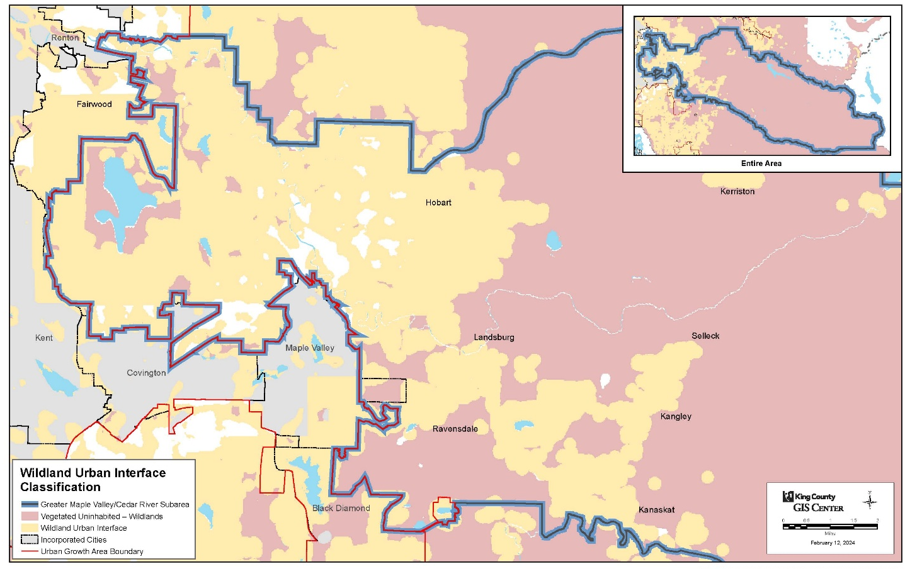

Increased heat events
Since the 1960s, King County has experienced more frequent and longer heat waves. These heat impacts are worsened by features like paved surfaces and limited tree cover, making temperatures in urban areas up to 20 degrees Fahrenheit hotter than in less developed regions. While extreme heat affects urban areas most intensely, rural communities such as the Greater Maple Valley/Cedar River subarea may also experience these increased temperatures, which can have serious consequences for agricultural workers, outdoor laborers, and those with limited access to air conditioning.

Extreme heat refers to temperatures that are significantly higher than the typical range for a region and can persist for several days, posing health risks to people, animals, and infrastructure. Extreme heat increases hospitalizations and mortality, with the greatest impacts on vulnerable groups such as the elderly, underserved communities, outdoor workers, people experiencing homelessness, and those with chronic health conditions. By 2050, the region is projected to be 5.5 degrees Fahrenheit hotter, with urban areas in King County experiencing an average of 25 additional extreme heat days per year. Rural areas may also face longer periods of heat, placing additional stress on residents and agricultural systems. ,02F

Implementation Plans and Programs Relevant to the Environment
Many existing programs and plans within King County address improving environmental health, conserving open space, enhancing natural systems, and upholding Tribal treaty rights. Below is a list of key County plans and initiatives related to the environment:
Clean Water Healthy Habitat
A program with a 30-year lens to align the County’s goals of healthy forests and more green spaces; cleaner, controlled stormwater runoff; reduced toxics and fecal pathogens; functional rivers and floodplains; better fish habitat; and resilient marine shorelines.
Strategic Climate Action Plan
A five-year blueprint for County climate action, initially adopted in 2012, integrates climate change into all areas of County operations and work with King County cities, partners, communities, and residents.

Flood Management Plan
The flood plan sets floodplain management policy for unincorporated King County and could inform flood management actions by cities, the King County Flood Control District, and other floodplain partners.
30-Year Forest Plan
A plan developed to provide a shared countywide vision for rural and urban forest cover and forest health. It includes priorities, goals, and strategies for achieving that vision over the next 30 years.

Regional Hazard Mitigation Plan
This plan assesses natural and human-caused hazards that can impact our region, including hazards discussed during engagement with the subarea, such as floods, landslides, severe weather, and wildfires. This plan develops strategies to reduce risk and build resilience.
Open Space Plan
The 2022 King County Open Space Plan: Parks, Trails, and Natural Areas (Open Space Plan) establishes both a strategic and functional plan to comply with the Washington State Growth Management Act and meet Washington State Recreation and Conservation Office grant requirements. The Open Space Plan provides a framework for expanding, planning, developing, stewarding, maintaining, and managing the County’s complex system of 220 parks, 185 miles of regional trails, and 32,000 acres of open space.
Wildfire Risk Reduction Strategy
A strategy to reduce fire risk in King County by increasing the resilience of King County forests to wildfire; increasing wildfire preparedness, response, and recovery within the wildland urban interface; and responding quickly, effectively, and safely when wildfires occur.
Land Conservation Initiative
A collaborative strategy to preserve King County’s last, most important natural lands and urban green spaces through a series of accelerated actions to address rapidly shrinking open spaces and climbing land prices. Conservation Futures funding is the primary source for the Land Conservation Initiative.
Lake Washington/Cedar/Sammamish Watershed (WRIA 8) Chinook Salmon Conservation Plan (2025)
The plan recommends actions to restore and protect habitat that salmon need to survive in the Lake Washington/Cedar/Sammamish Watershed. Developed through a collaboration of community members, scientists, businesses, environmental groups, local elected officials, and public agency staff, the science-based plan has been ratified by 24 local governments. The intent is to lead the region toward a legacy of healthy, harvestable salmon and improved water quality for future generations.

Water Inventory Resource Area (WRIA) 9 Salmon Habitat Plan (2021)
WRIA 9 in King County corresponds to the Green-Duwamish and Central Puget Sound Watershed. It includes the Green River basin, the Duwamish River, and smaller streams that flow into Elliott Bay and central Puget Sound. The updated plan represents the next chapter of salmon recovery efforts in watersheds. It provides a science-based framework for identifying, prioritizing, and implementing salmon recovery actions over the next 10 to 15 years. The Plan Update integrates over a decade of new science and monitoring; provides updated habitat goals; outlines refined recovery strategies and embedded policies and programs; updates the capital projects list; and outlines a monitoring and adaptive framework for tracking implementation and making strategic adjustments.

Community Priorities
- Commitment to preserving forests in the subarea. Preserving forests is a key priority, with strong support for maintaining healthy ecosystems, reducing wildfire risks, and protecting biodiversity. Residents value the role forests play in sequestering carbon, regulating water quality, and serving as critical wildlife habitats. There is also broad recognition of the increasing wildfire threat, leading to calls for active forest management strategies, such as controlled burns, selective thinning, and improved fire mitigation measures within residential areas. Many believe conservation efforts should be balanced with responsible forestry practices to protect both environmental and economic interests.
- Strong interest in restoring habitat. Habitat restoration and wildlife protection are areas of significant concern, with many advocating for efforts to restore salmon runs, protect endangered species, and reduce the spread of invasive plants like knotweed and English ivy. There is support for tax incentives and conservation programs that encourage property owners to preserve native vegetation and maintain wildlife corridors. Many see habitat restoration as essential for maintaining the ecological balance of the region and preventing further loss of biodiversity.
- Water and air quality conservation are priorities. The Cedar River and its watershed are central to many discussions, with concerns about pollution, habitat degradation, and the need for stronger water management policies. There is support for stricter regulations, including increased monitoring of industries where runoff is directly discharged into rivers, to protect local water bodies from industrial runoff as well as increased monitoring of pollution levels, including category 1 critical aquifer recharge areas that are also classified as at high risk for groundwater contamination. Efforts that promote responsible water use, reduce waste, and enhance stormwater management are widely supported.
- Cedar Hills Regional Landfill and the adjacent Cedar Grove Compost Facility. Both have caused residents to voice frustration over toxic emissions from the leachate ponds and odor pollution and air and water quality impacts and mitigation, if at all, takes years to accomplish.
- Environmental protection with rural levels of growth in the subarea. Community infrastructure and sustainable development planning have emerged as major issues, with residents emphasizing the importance of balancing population growth with environmental protection. Concerns about increasing residential density near environmentally sensitive areas have led to calls for more comprehensive planning efforts that prioritize ecological preservation. Many believe that County policies should be more flexible for individual landowners while also holding large-scale operators/developers accountable for their oversized environmental impacts. There is strong interest in third-party environmental assessments, stricter permitting guidelines, and greater involvement of community oversight groups to ensure that regulatory decisions reflect community priorities for environmental protection.

- Mine reclamation processes. Community members expressed concern about oversight of mine reclamation processes, calling for measures to ensure that such properties are restored to their pre-mining forestland condition in a timely manner.

- River water flows. Residents along the Cedar and Green Rivers want to ensure levees are adequately maintained to provide protection against catastrophic impacts.
- Environmental Impact Statements (EISs). Concerns were expressed that all too often for proposed or extended mining operation permits with large potential impacts that KC issues Determinations of Nonsignificance (based on applicant-supplied Environmental Checklists), which then do not trigger obviously needed EISs effectively circumventing the intent of the State Environmental Policy Act (SEPA). When evaluating the Acceptable Source Impact Level (ASIL) to determine “nonsignificance,” consideration should be given to the combined effect of multiple toxins and not rely on individual levels.

Policy
GMVCR-9 Promote flood resilience and salmon recovery in the Cedar River and Green corridors and their notable tributaries by strengthening coordination and collaboration between the County, City of Seattle, the Flood Control District, Indian Tribes, and other partners.
GMVCR-Ch6a Ensure all mining permits are accompanied by a specific mine reclamation plan, including reclamation timing, fill volumes and material; that will restore the mined land as close to its pre-mining condition as practical (including impacts on surrounding lands and waters) in a timely manner.
GMVCR-Ch6b Ensure a CHRLF closure plan is developed including schedule with specific measurable milestones based on no further expansion after the current 2019 KCSWD Comprehensive Plan is complete.
GMVCR-Ch6c Ensure monitoring of groundwater, water quantity and quality of the Cedar and Green River watersheds provide decades of clean water to the entire area—groundwater monitoring needs to include checking for additional toxins beyond the eight recommended in US EPA guidelines.
GMVCR-Ch6d Investigate the restoration of legacy wetlands—some shown on 1895 United States Geological Survey (USGS) maps.

GMVCR-Ch6e

GMVCR-Ch6f Monitor, repair, and continually maintain critical levees along the Cedar and Green Rivers to ensure safety of downstream residences and properties.

GMVCR-Ch6g Monitor environmental friendly human recreational activity near watersheds and reservoirs to limit contaminants to the water.

GMVCR-Ch6h Work with school districts to develop classroom curriculum for grade school children to learn about our shared environment to highlight reduce, reuse and recycling, as well as groundwater contamination, flooding mitigation, landslides and erosion.

GMVCR-Ch6i Mitigate for known CHRLF hazards to ensure necessary fixes are developed and applied to maintain Public health and safety.

GMVCR-CH6j Increase monitoring severity and frequency for run-off and discharge from industrial business into lake, rivers, tributaries, and wetlands, in general, and for the Cedar Grove Compost facility, specifically.

Encyclopedia of Puget Sound webpage. [LINK]
Flooding in King County Watersheds webpage. [LINK]
King County Flood Management Plan. [LINK]
Flooding in King County Watersheds webpage. [LINK]
King County Flood Control District website [LINK]
U.S. Environmental Protection Agency. 2016. What Climate Change Means for Washington. EPA 430-F-16-049. August [LINK]
University of Washington Climate Impacts Group State of Knowledge Report. [LINK]
Link to King County, “Confronting Climate Change” Infographic
King County. “Drought Preparedness.” King County, WA. [LINK]
Mote, P. W., Li, S., Lettenmaier, D. P., Xiao, M., & Engel, R. (2018). Dramatic declines in snowpack in the western US. npj Climate and Atmospheric Science, 1(1), Article 2 [LINK]
U.S. Environmental Protection Agency. (2024). Climate change indicators in the United States: Snowpack. [LINK]
Breda, Isabella. 2022. “Climate Change Could Make WA Streams Too Hot for Fish, Report Shows.” The Seattle Times, December 13, 2022. [LINK]
Compared to 1971-2000.King County Flood Management Plan, 2024. [LINK]
Mauger, G. S., Casola, J. H., Morgan, H. A., Strauch, R. L., Jones, B., Curry, B., Busch Isaksen, T. M., Whitely Binder, L., Krosby, M. B., & Snover, A. K. (2015). State of knowledge: Climate change in Puget Sound (Climate Impacts Group, Univ. of Washington). Puget Sound Partnership & NOAA. [LINK]
According to the Centers for Disease Control and Prevention, wildfire smoke can cause respiratory and cardiovascular harm, including worsened asthma and reduced lung function; those most at risk include children, older adults, people with preexisting respiratory conditions, and individuals experiencing homelessness who may have limited access to clean indoor air. [LINK]
Climate Change Indicators: Heat Waves [LINK]
King County Executive. "Results of Heat Mapping Project Show Inequitable Impact of Hotter Summers, Will Inform Actions by King County and City of Seattle." King County, Washington, June 23, 2021. [LINK]
Link to “Impacts of extreme heat on emergency medical service calls in King County…,” [LINK] Environmental Health, Link to “Increased mortality associated with extreme-heat exposure in King County…,” [LINK] International Journal of Biometeorology, Link to “Increased hospital admissions associated with extreme-heat exposure in King County…” [LINK]
Climate change impacts in King County, (2025)[LINK]
Washington State Department of Health, Washington Tracking Network, (2025) [LINK]
King County Clean Water Healthy Habitat webpage, (2025). [LINK]
King County Strategic Climate Action Plan webpage, (2025). [LINK]
King County Flood Management Plan webpage, (2025). [LINK]
King County 30-year Forest Plan webpage, (2025). [LINK]
King County Regional Hazard Mitigation Plan webpage, (2025). [LINK]
King County Open Space Plan: Parks, Trails, and Natural Areas (2022). [LINK]
King County Wildfire Risk Reduction Strategy (2022). [LINK]
King County Land Conservation Initiative webpage, (2025). [LINK]
WRIA 8 Chinook Salmon Conservation Plan webpage, (2025). [LINK]
WRIA 9 Salmon Habitat Plan Update webpage, (2025). [LINK]

