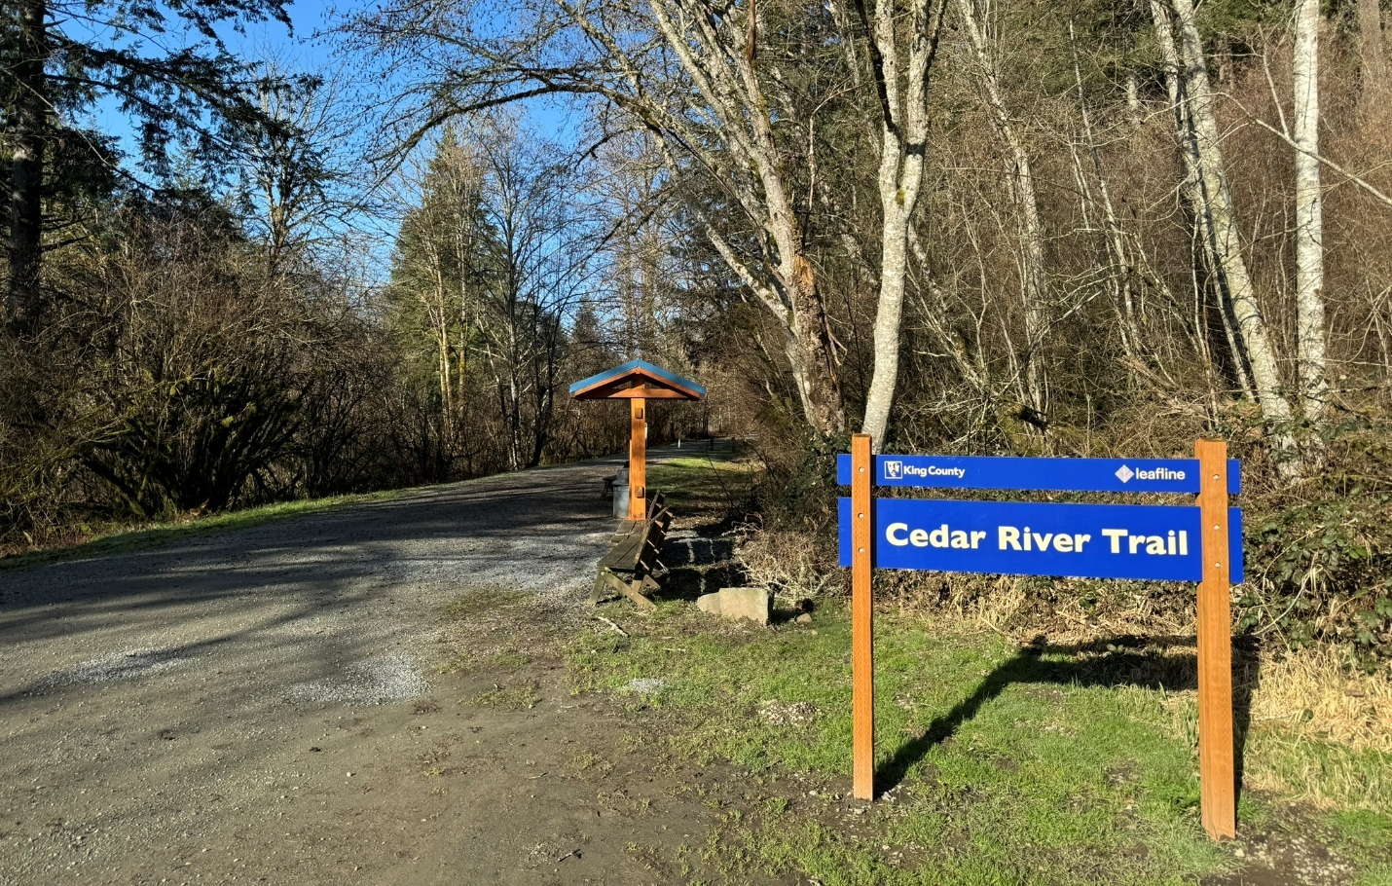

Chapter 7: Parks, Open Space, and Cultural Resources
The Greater Maple Valley/Cedar River subarea hosts a diverse array of parks, open spaces, and areas of cultural significance. The subarea includes forests, rivers, trails, and lakes and ponds, providing critical habitat for wildlife, and offering residents and visitors abundant opportunities for recreation and connection with nature. The King County Department of Natural Resources and Parks owns and manages many of the iconic parks and open spaces and supports ongoing maintenance and recreational opportunities through several grant programs.
The subarea includes sites of historic and cultural significance; King County supports these resources through community-based funding, while the King County Historic Preservation Program designates landmarks, provides technical assistance, and helps protect heritage across rural communities.
The 2022 King County Open Space Plan: Parks, Trails, and Natural Areas (Open Space Plan), a functional plan of the Comprehensive Plan, provides the policy framework for the County's acquisition, planning, development, stewardship, maintenance, management, and funding of its system of 220 parks, 185 miles of regional trails, and 32,000 acres of open space.
According to the Open Space Inventory, there are five recognized local parks, 28 regional parks that include natural areas, open spaces, and forests, and five regional trails in the boundaries of the subarea. Several natural areas, multi-use sites, and recreation areas are found along the Cedar River in the neighborhoods of Landsburg and Ravensdale. Additionally, many natural areas, multi-use, and flood hazard properties are located along State Route 169 and the Cedar River in the Maple Height-Lake Desire neighborhood. With nearly 300 square miles of Forest Production District land, the Greater Maple Valley/Cedar River subarea includes working forest lands, most notably the Taylor Mountain Forest and Sugarloaf Mountain Forest. These natural spaces and water bodies provide unique recreational opportunities to residents in the subarea.
Figure 17 Map of Parks, Open Space, and Public Lands

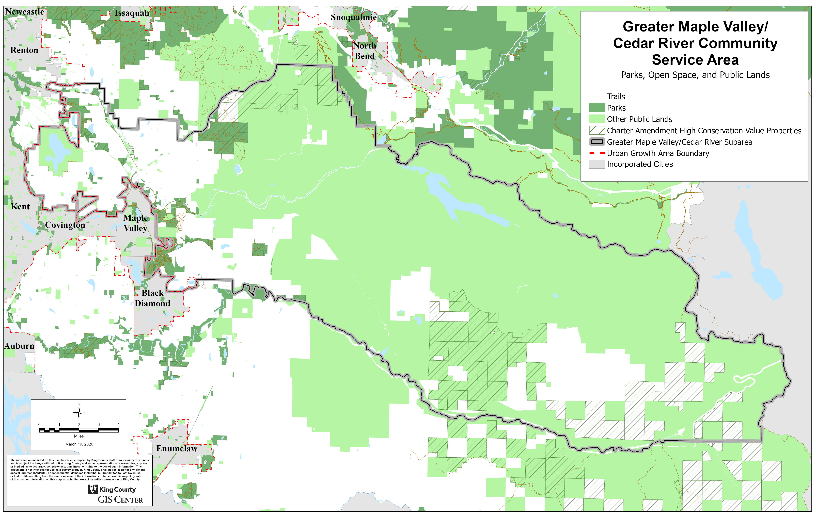

Parks and Open Spaces
King County manages many parks and natural areas within the subarea, each offering unique recreational opportunities and ecological functions. Taylor Mountain Forest, located just east of Maple Valley, spans 1,822 acres of diverse landscapes that include dense forests, wetlands, riverine systems, and meandering streams. Area parks offer a variety of recreational experiences, such as hiking, walking paths, horseback bridleways, ATV and dirt bike riding, and mountain biking, while serving as an important wildlife corridor for species such as coyote, deer, elk, lynx, cougar, and black bear. Similarly, the Black Diamond Open Space, covering more than 1,200 acres, is a popular destination for outdoor enthusiasts, featuring extensive trail systems that support an active outdoor lifestyle.
Forested areas not only provide recreational value but also play a critical role in protecting water quality and enhancing regional biodiversity.
The near 400-acre Lake Desire Natural Area is situated near the north subarea boundary. It is a tranquil retreat surrounded by wetlands, marshes, lakes and forested landscapes. The area offers walking trails, birdwatching opportunities, and recreational activities such as mountain biking, fishing and eco-friendly boating, making it a valuable resource for passive recreation and environmental preservation.
Additionally, the Landsburg Park and Natural Area is located near the Cedar River. It provides access to scenic hiking trails and river-based activities like fishing, tubing and kayaking. The park’s strategic position within the Cedar River watershed is pivotal in the importance of maintaining water quality and supporting salmon habitat in the unincorporated areas of King County.
An extensive trail network further enhances connectivity and accessibility across the subarea, linking communities to parks, open spaces, and natural features. The Cedar River Trail, a 17.3-mile paved and gravel pathway, follows the course of the Cedar River from Renton through Maple Valley, offering scenic vistas and opportunities for walking, running, and cycling. As a major regional corridor, the Cedar River trail connects to other key routes, facilitating non-motorized transportation and recreation across southeast King County. The developing Green-to-Cedar River Trail aims to create an interconnected pathway linking the Cedar River Trail to the Green River Trail, enhancing recreational access and providing a seamless connection between urban and rural areas.

Water Features
The Cedar River, a prominent natural feature, provides essential habitat for salmon and other aquatic species, supporting critical life cycles and contributing to biodiversity. As a key waterway, it plays a significant role in regional water quality and flood management efforts, helping to regulate stormwater runoff and provide clean drinking water to the cities of Renton and Seattle. In addition to its ecological importance, the Cedar River offers popular recreational activities, such as fishing, kayaking, tubing, and nature observation, drawing visitors who seek to experience its natural beauty.
The Green River, flowing along the entire southeastern edge of the subarea, works together with the Cedar River and other riverine systems to help regulate water movement through the region, including river flows, groundwater, and overall water levels. It serves as an essential water source and provides opportunities for recreational activities, such as angling, kayaking, floating, and wildlife observation.
There are many local lakes nestled within serene natural settings that offers a peaceful retreat for residents and visitors alike. Surrounded by forested areas and wetlands, many lakes support low-impact recreational activities, such as fishing, non-motorized boating, and birdwatching. These lakes are an asset for passive recreation while also playing a crucial role in local conservation efforts. Efforts to maintain the lake’s water quality and natural surroundings help preserve its ecological integrity and enhance its appeal as a community resource.

Cultural Resources
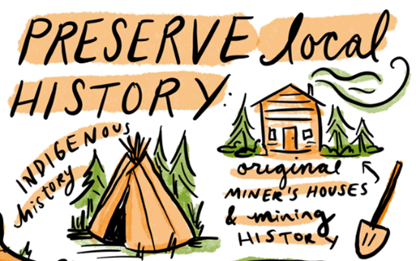
The subarea’s cultural resources reflect the region’s rich heritage and longstanding ties to both industrial roots and Indian Tribal history. The subarea hosts several historical landmarks that showcase its coal mining and logging past. These sites offer a window into the area's early industrial development and provide educational opportunities for visitors interested in learning about the region’s cultural legacy. The preservation of these landmarks helps maintain a connection to the past while contributing to the area's unique identity.
Image 16 Artist Natalie Dupille
The Cedar River Watershed Education Center, located outside of the subarea, serves as an important hub for environmental education and community engagement. Located near the Cedar River, the center provides educational programs that highlight the watershed's critical role in supplying clean water to the region. It offers insights into the ecological and cultural significance of the river, fostering a deeper understanding of the natural systems that sustain the community.
The County partners with local Indian Tribes to preserve ancestral lands and cultural heritage within the subarea. These collaborations ensure that Tribal perspectives are integrated into the stewardship of parks, natural areas, and cultural sites. Efforts to honor and protect sacred lands, enhance cultural education, and involve Tribal communities in decision-making processes help strengthen the region’s cultural identity and promote inclusive land management practices.

King County Plans and Programs Relevant to Parks, Open Space and Cultural Resources
Many existing programs and plans within King County meet regional and local community needs for parks and open space. For this reason, it is important to note the connections between existing programs, policies, and plans that cover these topics within the subarea.
Conservation Futures
In 1971, Washington State authorized the Conservation Futures Tax (CFT) levy, allowing counties to collect a small levy from landowners to protect open space. King County is one of 14 counties statewide that levies a conservation futures tax – protecting forests, shorelines, farms, greenways, and trails for future generations to enjoy forever.

Open Space Plan
The 2022 King County Open Space Plan: Parks, Trails, and Natural Areas (Open Space Plan) establishes a strategic and functional plan to comply with the Washington State Growth Management Act and meet Washington State Recreation and Conservation Office grant requirements. The Open Space Plan provides a framework for expanding, planning, developing, stewarding, maintaining, and managing the County’s complex system of 220 parks, 185 miles of regional trails, and 32,000 acres of open space.
King County Parks Levy
A voter-approved property tax levy that supports parks, trails, and open space in King County. In August 2025, almost 73 percent of voters approved a renewed six-year Parks Levy ballot measure. The revenue generated by this levy provides countywide investments in parks, trails, recreation, and open space protection for the benefit of all King County residents, including the subarea. The 2026-2031 King County Parks levy has allocated $18 million to undertake planning efforts for future regional trail connections, including regional trails that serve the subarea.
30-Year Forest Plan
A plan developed to provide a shared countywide vision for rural and urban forest cover and forest health. It includes priorities, goals, and strategies for achieving that vision over the next 30 years.
Land Conservation Initiative
A collaborative strategy to preserve King County’s last, most important natural lands and urban green spaces through a series of accelerated actions to address rapidly shrinking open spaces and climbing land prices. Conservation Futures funding is the primary source for the Land Conservation Initiative.

Regional Trail Needs Report
The Regional Trail Needs Report (2024), an appendix of the King County Comprehensive Plan, provides planning level information regarding trail projects to consider in the future. The report includes general information about potential locations and costs. Levy funds will support the acquisition of land and development of new trails in the subarea.

King County Historic Preservation Program
The King County Historic Preservation program protects historic properties in King County. The program provides services such as historic resource survey and inventory, landmark designation and regulation services, review of developments that could impact historic resources, and more. A Historic Properties Map can be found on the program’s website.

Community Priorities
Community members expressed a strong commitment to preserving and enhancing parks, open spaces, and historic/cultural resources while balancing recreation and conservation. The feedback highlights key priorities such as the preservation of natural areas, expanding recreational opportunities, improving access to public lands, and fostering cultural and historical appreciation.
- Protect existing natural areas. Many residents emphasized the need to protect existing forests, open spaces, and natural landscapes, with some advocating for keeping areas in their untouched state. Conservation efforts should focus on maintaining wildlife habitats and connectivity, promoting biodiversity, and ensuring that future development or industry does not encroach on or impact critical ecological areas. There is a particular emphasis on maintaining rural character while allowing for thoughtful, limited recreational development that does not compromise the natural beauty of the region.

- Access to lakes and rivers. Water-based recreation remains an area of interest, with calls for expanded access to lakes and rivers for activities such as kayaking, fishing, and swimming. Community members want to see more spaces that provide direct access to water while ensuring that conservation measures are in place to protect aquatic ecosystems.
- Create and maintain active recreation and community spaces. Strong desire to improve sports fields, creating additional off-leash areas for dogs, and providing dedicated spaces for cultural and educational activities. There is also interest in reintroducing recreational opportunities that have declined over time—such as roller skating—and developing specialized parks, like horse parks, to better support equestrian use.
- Calls for public amenities with open space. Community members expressed a desire for user-friendly enhancements to open spaces, including parking near high-use recreation areas, improved signage, garbage cans, restrooms, picnic and gathering areas, and interpretive signage highlighting cultural and natural features.
- Support for access to public lands. Community members expressed a strong desire for improved access to public lands, particularly along the Cedar River, to enhance recreation and enjoyment of natural resources.

- Hobart Johnny Lazor Ballfield. Members of the community support expanding the Hobart Johnny Lazor Ballfield in the Hobart area to include additional amenities, such as parking, picnic areas, and a play structure. It has been in continuous use since 1890 (Baseball) and honors Johnny Lazor, who played for the Boston Red Sox from 1943-1946 (the first Major League player from the Hobart area). Residents wish to honor their history and preserve this significant and historic ballfield for future use by all residents and Maple Valley PONY Baseball. Residents mentioned their wish to have a monument installed to recognize the former Hobart School and Gymnasium’s location along with adding additional amenities such as expanding the parking lot and adding a picnic area and play structures, as per the 1984 Tahoma Raven Heights Community Plan.
- Ravensdale Park and Meadow. Members of the Ravensdale community support expanding the Ravensdale Park with its Meadow area to include additional amenities, , adding a Community Area Building, and completing Phase 3 of Ravensdale Park Sports facilities by the Department of Natural Resources and Parks.

- Support for linking regional trail systems. There is community interest in regional trail connections:
  - Linking Lake Youngs to the Cedar River Trail
  - Establishing the Landsburg-Kanaskat Trail
  - Continuing the regional trail network to Enumclaw along the planned Foothills Trail corridor
  - Linking Covington Community Park/Tahoma National Cemetery with the Soos Creek Regional Trail through existing utility corridors
  - Investigating means to utilize the existing 5-mile public trail easement on Ravensdale Ridge to connect Green-to-Cedar Trail to the Green River (north side) trail
- Local trail concepts. Community members shared trail ideas based on past planning efforts and local initiatives.

- Suggestions included developing trails proposed by the Friends of Rock Creek Valley Additional trail opportunities were identified in the areas around Sugarloaf Mountain and Lake Sawyer.

- Support for passive recreational trails. There is strong support for expanding backcountry trails dedicated to hiking, horseback riding, running, nature observation and mountain biking. Additionally, regional trails that accommodate shared-use activities, such as cycling, jogging, and horseback riding, are widely supported. Many residents emphasized the importance of designating trails exclusively for equestrians and hikers to ensure safety and minimize conflicts with mountain bikers.

- Advocacy for a public equestrian center. Several community members expressed support for developing a public equestrian center with trail access within the subarea. Comments highlighted community interest in an equestrian facility similar to that envisioned by the Friends of Rock Creek Valley Horse Park. There was broad agreement that equestrians represent a key user group in the area.

- Support for investments in cultural resources. Ensuring that cultural and historical resources remain protected and accessible for educational and recreational use is viewed as essential to fostering a strong sense of identity and connection to the region. Residents place high value on the region’s historical sites, natural landmarks, and lands of Tribal significance. There is strong support for maintaining and celebrating these assets through pursuit of historic designations, other historic preservation efforts, community events, interpretive signage, and partnerships with local Indian Tribes.

- Enforcement of encampment regulations. about unauthorized camping in open spaces, prompting calls for stronger enforcement and regulations to prevent environmental degradation.

Policies
GMVCR-10 Evaluate opportunities to support youth and adult athletics through coordination with community partners to seek funding for development and management of associated parks facilities, such as Hobart Johnny Lazor Ballfield and Ravensdale Park.
GMVCR-11 Evaluate opportunities to expand equestrian trails, parking, and increased accessibility through such means as feasibilities studies.

GMVCR-Ch7a Develop and maintain a permitting process wherein a checklist is prepared that ensures long-term maintenance of the rural environment, natural resources and eco-friendly preservation of the land, while allowing property owners to pursue opportunities to live a simple, self-reliant, and nature oriented country life-style including farming, forestry, agriculture, livestock management, and animal husbandry.
GMVCR-Ch7b Increase access to public use of local waterways with rules in place to limit activities that are harmful to aquatic ecosystems: use of eco-friendly watercraft, strict beach use area designators, game warden checks on proper fishing laws, and improved river access points to reduce erosion to river banks.
GMVCR-Ch7c Develop plans to expand and improve area sports venues to include paved paths for non-motorized wheeled sports equipment use (roller skates and blades), off-leash open areas for canine exercises, dedicated specialized parks for equestrian use, picnic and family gathering areas, improved parking, handicap accessibility, restroom availability, entry points and signage for cultural and natural features.

GMVCR-Ch7d Link various trail networks as part of the Open Space Plan—Parks, Trails, and Natural Areas, an example is the connection of the Soos Creek Trail with Covington Community Park and theTahoma National Cemetery.

GMVCR-Ch7e Designate certain trails for pedestrian and equestrian use only.

GMVCR-Ch7f Work with local interest groups to develop a plan to create an equestrian facility similar to Pierce County’s Frontier Park that encompasses a wider variety of equestrian sporting activities.

GMVCR-Ch7g Provide public access to local cultural and historical areas, as defined by King County, with signage detailing the significance of the area and work with local indigenous tribes to identify areas of cultural interest and area historical societies identify significant cultural and historic sites.

GMVCR-Ch7h Develop rules and regulations that defines temporary camping sites.

King County Open Space Plan: Parks, Trails, and Natural Areas (2022). Includes updated statistics from May 2025. [LINK]
King County Open Space Plan: Parks, Trails, and Natural Areas (2022). [LINK]
King County Conservation Futures webpage, (2025). [LINK]
King County Open Space Plan: Parks, Trails, and Natural Areas (2022). [LINK]
King County Parks Levy webpage, (2025). [LINK]
King County 2026-2031 Parks Levy Renewal Allocation Plan, Attachment A to Motion 16797 [LINK]
King County 30-year Forest Plan webpage, (2025). [LINK]
King County Land Conservation Initiative webpage, (2025). [LINK]
Regional Trail Needs Report, 2024 King County Comprehensive Plan, Appendix C2 [LINK]
King County Historic Preservation Program, (2025) [LINK]

