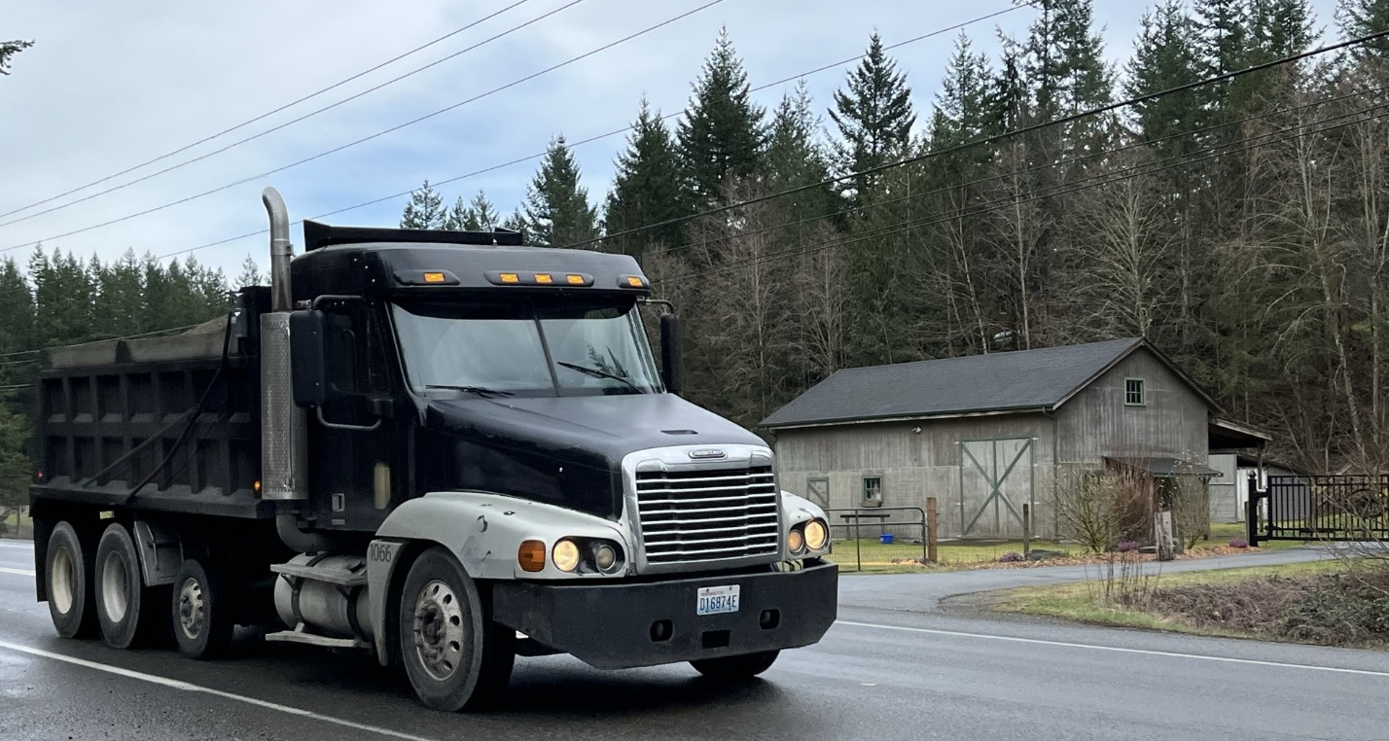

Chapter 8: Transportation
Transportation plays a significant role in the quality of life and the economic vitality of any region. A well-planned and maintained transportation system provides access to jobs, education, services, recreation, and other destinations.
The Greater Maple Valley/Cedar River subarea’s highways and county roads connect King County to neighboring counties, link urban employment centers to residential communities, transport freight from farms and other resource-based businesses to markets in the Pacific Northwest and beyond, and provide residents with access to services and programs in nearby cities. The network of roads, bridges, paths and trails, transit service, and related infrastructure support the well-being of the community, while providing rural levels of service.
Transportation Planning
Transportation planning in the Greater Maple Valley/Cedar River subarea is shaped by state law, including the Growth Management Act, which requires that rural areas receive transportation services that maintain their rural character and do not encourage urban levels of development. Transit service in the area is also guided by Metro’s policies, such as the Service Guidelines and Metro Connects.
The transportation system in this subarea faces several significant challenges. These include limited funding, the impacts of climate change, population densities that are too low to support frequent, dedicated transit routes, and increasingly high volumes of through traffic between isolated outlying cities and urban core cities. Like the rest of unincorporated King County, the transportation needs of the subarea far exceed the available resources.
Climate change presents additional challenges. Flooding, landslides, and major storms are happening more often and are more damaging, leading to road closures, costly repairs, and blocked access to both everyday destinations and emergency services.
As King County continues to grow, roads in the Greater Maple Valley/Cedar River area are experiencing more traffic and congestion due to growth in adjacent cities. The rural area itself is experiencing little growth other than infill of vacant parcels due to the rural factors represented in the zoning code.
Like other parts of the county, much of the area's road infrastructure is aging and was not designed to handle current traffic volumes. Higher traffic volumes increase the difficulty of local access to/from local side streets and driveways. Roads built originally for low-volume purposes in a farming environment lack shoulders and other roadside amenities suitable for pedestrians, bicyclists, and equestrian uses in parallel with higher volumes of urban-oriented through travel. While some residents depend on public transit, the area’s lower population density and limited ridership do not meet Metro’s current criteria for expanded service for subarea residents.
The transportation policies in the King County Comprehensive Plan aim to meet the needs of the Rural Area and Natural Resource Lands without encouraging additional development or growth pressure. These policies focus on maintaining and preserving roads and other infrastructure to support the safe and efficient movement of people and goodsand discourage expansion of rural area roads to serve through travel except on designated Rural Regional Arterials designated to serve through travel. This is essential for both the economic health of the Greater Maple Valley/Cedar River subarea and the region’s broader trade and transportation networks. The comprehensive plan lends support to road improvements that benefit "active transportation" - pedestrians, bicyclists, and equestrians - in keeping with rural area levels of service. However, it is impossible to achieve those and other goals given the enormous deficit of revenues for the County Road Fund.

INSERT FIGURES AND TABLES SHOWING CURRENT AND 2050 FUTURE SUBAREA POPULATION, EMPLOYMENT, AND TRIPS GENERATED, PER VISION2050. INCLUDE SAME DATA FOR ADJACENT CITIES: BONNEY LAKE, BUCKLEY, ENUMCLAW, BLACK DIAMOND, MAPLE VALLEY, COVINGTON, AND KING COUNTY TOTAL.

INSERT A MAP OF ACCIDENT LOCATIONS AND FREQUENCY ON THE SUBAREA ROADS. ADD A TEXT DISCUSSION OF TYPES OF ACCIDENTS AND COMPARISON TO COUNTYWIDE OR STATEWIDE AVERAGE ACCIDENT EXPERIENCE.

King County Plans and Programs Relevant to Transportation
In addition to the Comprehensive Plan, transportation and mobility services are carried out through several agency plans, including:

The King County Strategic Plan for Road Services
The King County Strategic Plan for Road Services guides the Road Services Division in maintaining and operating the County’s rural and unincorporated road system. The plan prioritizes preserving essential infrastructure, managing service levels based on usage and priority considering the severe lack of funding for all needs, and planning for long-term needs.

The King County Metro Strategic Plan for Public Transportation 2021-2031
The King County Metro Strategic Plan for Public Transportation 2021–2031 outlines Metro’s goals, priorities, and strategies for delivering and improving public transit services over a ten year period. It identifies service objectives, performance targets, and planned investments to guide decision-making and resource allocation for transit operations, facilities, and community connections throughout King County. At the level of funding afforded by current revenue streams, the amount of bus-hours and bus-miles per year that can be allocated to low-density rural areas is much lower than the service provided to high density urban areas.

The King County Metro Long Range Plan – Metro Connects
The King County Metro Long Range Plan – Metro Connects provides a long-term vision and framework for the future of public transportation in King County. It identifies system goals, network concepts, and investment strategies intended to guide transit development over multiple decades to better meet projected demand and support equitable access, sustainability, and regional mobility. This plan focuses most of its resources on the urban area of King County, but is a suitable context for consideration of commuter transit services through the rural area that connect isolated outlying cities with the cities in the urban core.

The King County Metro Service Guidelines
The King County Metro Service Guidelines establish criteria and standards for planning, evaluating, and adjusting Metro’s transit services. They are used to guide decisions about route design, service levels, performance measurement, and resource allocation to ensure consistency, efficiency, and responsiveness to community needs. With respect to rural areas, the Guideline state:........KC: please fill this in.
Existing Transportation Network

State Highways
The Greater Maple Valley/Cedar River subarea features two highways, State Route (SR) 169 and SR 18, which are owned and managed by the Washington State Department of Transportation (WSDOT). Both are classified as Principal Arterials, and they serve as the backbone of the subarea's transportation system, connecting the subarea's County road network to nearby cities as well as statewide destinations SR 169 is designated by WSDOT as a Highway of Statewide Significance, which elevates the route's importance in planning and improvement funding.

County Road System
The majority of the subarea’s road network consists of local roads and collector arterials in terms of miles, but the vast majority of traffic by volume occurs on minor arterials and principal arterials.

Table XX gives the total center-line miles of county roads in the subarea, by functional classification, and the total amount of vehicle-miles-of-travel carried on each part of the road system. A map of classified roadways is found -in Figure 18.
Principal Arterials
Principal arterials primarily serve through travel with low emphasis on access to adjacent properties. Principal arterials are few in number but carry a large portion of total travel. In this subarea, state highways SR169 and SR18 are the most important principal arterials. SE Petrovitsky Road is the only county road in the subarea classified as a Principal Arterial, and carries up to XX,000 daily trips as it enters Fairwood to the west of the subarea.
Subarea residents depend on Issaquah Hobart Road for connections north to Issaquah, but that Principal Arterial is technically outside the boundaries of the subarea. At its northern end entering Issaquah, that road carries 20,000 daily trips and is one of three designated Rural Regional Arterials,. That high volume of traffic is largely intercity travel not originating in the rural area per se, with sources as far away as Bonney Lake in the south and Redmond, Bellevue, and Seattle to the north..

Minor Arterials
Minor arterials provide a mix of access to adjacent properties and service to through travel, and may carry moderate to high traffic volumes depending on the location. Minor arterials are more numerous than principal arterials. Some minor arterial routes identified in Figure 18 undergo several name changes while providing a single long-distance corridor for through travelers:
276th Avenue SE is the extension of Issaquah Hobart Road southward from SR18 through Hobart, becoming Landsburg Road SE from approximately SE 240th St (at the closed Landsburg landfill) to Kent Kangley Road in Ravensdale, then proceeds as Ravensdale Way toward Black Diamond where it ultimately is named Black Diamond Ravensdale Road. This path to Issaquah is used by trips out of Enumclaw and Pierce County, as well as Black Diamond and some Maple valley neighborhoods.
SE Kent Kangley Road intersects with Landsburg Road SE / Ravensdale Way SE at the important Ravensdale Intersection, and connects from Maple Valley 's Four Corners commercial area to Retreat Kanaskat Road at the Ravensdale "Wye" intersection. The Retreat Kanaskat Road in turn connects to Cumberland Kanaskat Road which crosses over the Green River and the Auburn-Yakima Stampede Pass railroad track, to connect southward to the Enumclaw Plateau area of the Southeast King County Subarea.
SE 216th Street and its western end as SE 216th Way connect between SR169 and 276th Avenue SE. As well as providing access to adjacent parcels, it serves through travel connecting to the areas served by those connecting arterials.
SE Cedar Grove Road connects between SR169 and Issaquah Hobart Road. Only a small portion on the western end at SR169 is actually in this subarea. Most of that road is in the Four Lakes Tiger Mountain subarea, but it is used by many subarea residents as well as by longer distance through trips.
West of SR 169, the dominant minor arterial running north-south is 196th Avenue SE, which connects Covington to SR 169 far to the north. This route serves a large amount of local travel including substantial farming areas where both horses and cattle can be seen.
In the east-west direction, SE 240th Street links the northern tip of Maple Valley with the northernmost part of Covington and ties to the East Kent and Fairwood areas just outside the subarea, where 148th Avenue SE and 140th Avenue SE provide north-south connections.

Collector Arterials
Collectors provide access to adjacent properties, connect residential areas, and serve as links from neighborhoods to principal and minor arterials. Collectors usually do not have great length, as through travel should be a minimal component of use compared to local access. In Figure 18, thirteen collector arterials are depicted.

Local Roads
Local roads provide access to individual properties, are relatively short in length, and carry only low volumes of traffic in keeping with local access. They are officially unclassified; i.e., not arterials and so not intended for through travel. In Figure 18 a large number of local roads are shown without any arterial classification.

Figure 18 Map of Road Classifications and Metro Transit Routes
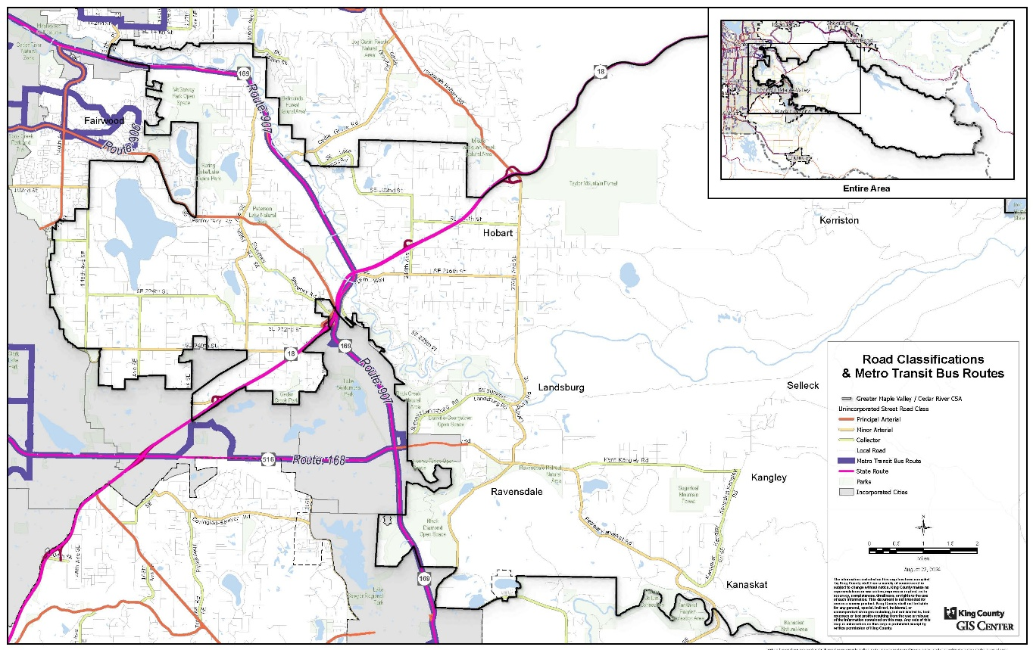

King County Roads Services
The King County Department of Local Services, Road Services Division is responsible for the operation and maintenance of the road system in all unincorporated areas of the County, whether rural or urban.

Financial Constraints (move this section below Services Provided)
The County’s ability to maintain and improve its road network is limited by a lack of revenue. This lack of revenue is in part because the County’s Road Fund relies on a small tax base relative to the size and age of the unincorporated road network, and the stark reality that the majority of trips using county roads are made by residents of cities (and businesses in cities) which do not pay anything into the County Road Fund. The County is further limited by the state’s one percent cap on property tax.
As a result of these factors, there is insufficient funding to fully maintain the county road system, and no funds are foreseeable to provide the capital improvements identified in the Transportation Needs Report(citation?). Instead, the County prioritizes its roads funding on critical safety needs, emphasizing core maintenance and operations to improve the system’s safety and usability.

TABLE XX.
[Add a table here, showing the lane miles and vehicle-miles of travel on each class of road, and separating the locally generated travel from the intercity through travel. You can get all that information from the PSRC travel forecasting model. And include the VISION 2050 growth numbers too. Or add a subsection about future growth and what that implies for county programs, following the public transit subsection.]

Services Provided
The Road Services Division provides a range of road-related transportation services, including the following list:
- Capital project construction (as funding allows)
- Pavement preservation
- Bridge inspection, maintenance, and repair
- Traffic operation through installation and maintenance of signals, signs, and pavement markings
- Maintenance activities such as pothole filling and vegetation, debris, and graffiti removal
- Safety investigations
- School zone safety improvements
- Traffic analyses
- Snow and storm response
- Emergency response services
- Customer services such as road alerts, 24/7 Helpline, adopt-a-road programs, and operation of the Map and Records Center
- Establishing and updating design standards
- Development review and permitting

Existing Assets (move this section ahead of Services Provided)
The County road infrastructure in the Greater Maple Valley/Cedar River subarea includes the following assets as of January 2025:

Figure 19 King County Road Assets, Greater Maple Valley/Cedar River Subarea
Asset | Quantity
Total centerline miles of road | 155 miles
King County maintained lane miles | 309 miles
Bridges | 25
Traffic cameras | 2
Traffic signals | 2
School zone flashers | 6
Traffic control signs | 4,229
Guardrails | 18 miles
Drainage pipes | 42 miles
Drainage ditches | 105 miles
Catch basins | 961
Sidewalks | 13,560 linear feet
Bike lanes | 3,406 linear feet
Crosswalks | 24

Public Transportation Services
Metro provides limited transit service to this rural subarea. Metro Service Standards (source?) allocate fewer bus-hours and bus-miles to rural areas than to urban areas, based on the lower density of homes and jobs that distinguish rural areas.
Route 168 connects a portion of the subarea to Downtown Kent via SR 516, from the Four Corners Commercial area in Maple Valley. Route 168 also is “through routed” with Route 161, so riders may travel all the way from Maple Valley to the SeaTac/Airport Link Station and on to Burien without changing buses.
Vanpool and Vanshare are additional options for commuters, and Access paratransit provides accessible service for riders with disabilities. Outside of the transit and ridesharing options described here, residents must rely on personal vehicles or other means of transportation.
King County Metro Dial-A-Ride (DART) Route 907 runs between Renton, Maple Valley, and Black Diamond. DART routes serve lower-density areas, acting as connectors between rural communities and between rural communities and larger cities. They are defined as having at least 35 percent of their route outside the urban growth boundary. DART routes can deviate from their fixed routing in lower-density areas. MOVE THIS PARAGRAPH ABOVE THE VANPOOL PARAGRAPH.

There is a substantial volume of intercity through travel on SR169 and certain county roads in the subarea, but there are currently no bus routes operating through the subarea from Black Diamond, Enumclaw, Buckley, and Bonney Lake into urban centers like Kent, Renton, and Issaquah, and beyond.
The Greater Maple Valley/Cedar River area is served by park-and-ride facilities that support transit and carpooling, including the Maple Valley Park and Ride on Maple Valley–Black Diamond Road SE at SE 232nd Street opposite the Maple Valley sheriff's office, and a lot at the Four Corners Town Square. These lots provide commuter parking and connections to King County Metro route 169, and DART Route 907, helping residents access nearby cities and regional transit hubs.

Active Transportation
The term "active transportation" is used in legislation and regulations to embrace all modes of travel that do not involve motor vehicles. Pedestrians and bicyclists account for most such activity, and in urban areas "rolling" is also common. In this rural subarea, equestrian activity is present, chiefly on trails managed by King County Parks, but occasionally on county roads.

Pedestrians
People walking or jogging are seen from time to time on virtually all roads, from local roads to heavily traveled arterials. The greatest conflict between pedestrians and motor vehicles arises where traffic volumes are high, speed is high, and/or sight distance is limited at blind curves and hillcrests. The highest frequency of pedestrian activity occurs in the vicinity of the neighborhood commercial centers in Hobart and Ravensdale, which are on minor arterial roads with moderately high traffic volumes. but all county arterials are used by pedestrians from time to time.
In rural areas, pedestrian activity may be supported by unpaved shoulders but must use the paved road surface if there are no shoulders. Although the county road standard calls for a shoulder width of eight (8) feet on new construction, there is almost no road in the subarea that actually has shoulders that width because all existing roads were constructed long ago when standards were lower. Most arterials have at least two feet of unpaved shoulders and some have four feet, but rarely more than four feet. Subarea residents have identified wider shoulders for pedestrians as a community need that has increased as intercity through traffic volumes have grown. The eight-foot standard shoulder is appropriate for principal arterials where service to through traffic predominates and shoulder parking should be accommodated, but lesser shoulder width may be adequate for minor arterials, collector arterials, and local roads where the primary need is to support pedestrian mobility and safety and traffic volumes are lower

Bicyclists
Bicyclists use many county roads for recreation and for commuting. The arterial routes used for commuting by automobile are also used by commuting bicyclists. Recreational cycling may occur anywhere, but is most common on county arterials that connect to urban areas and provide cyclists with superb scenic tours of the rural area on relatively level ground. On weekends and holidays, organized groups of bicyclists may be seen.

Bicycles with thin tires (i.e., excluding mountain bikes) require paved surfaces, and are legally recognized as road users. Where there is little or no paved surface outside the painted edge line, bicyclists have no option but to ride inside that line, despite the inherent danger to the bicyclists. On arterials with high traffic volumes, the requirement to share the road produces delays to motor vehicles as well, with sometimes inappropriate behaviors that are a form of "road rage". Relatively few county arterials have paved areas outside the edge line that are four feet wide or more. The County Road Design Standards do not show any provisions for bicycles.

Equestrians
Horses are commonly seen in the pastures of this rural area, and the Parks Department operates several trails used by horseback riders. For the most part, equstrians drive to trailheads hauling their horses in trailers. Horse riders are seldom seen on county arterials due to the conflict with motor vehicles, although that was more common long ago. Horseback riders may still be seen on low volume local roads.
Wide shoulders are used at some trailheads to park horse trailers, where there are no other off-road parking facilities.

Complete Streets Policy
The Complete Streets movement is a nationwide trend toward recognizing that pedestrians, bicyclists, and equestrians are road users as well as automobiles, trucks, and transit, and should be provided for in the design of roads. A variety of road configuration changes to implement the complete streets concept are found in urban settings. In rural areas, the principle is represented primarily as shoulder widening to support active transportation.
The King County Council enacted a Complete Streets Ordinance 202?-?? on ????????? which states: "xxxxxx". No specific action is mandated by that ordinance, until there is a funded road improvement action at hand.
Current county road standards do not yet include any specific guidance on how county roads should be designed to take pedestrians, bicyclists, and equestrians into account.

Community Priorities
Residents of the Greater Maple Valley/Cedar River subarea emphasize the need for transportation investments that address critical challenges and support community needs both long term and short term.
- Congestion on rural roads. Residents point to high traffic volumes on major intercity routes like Issaquah-Hobart Road and Highway 169, both of which struggle to accommodate current volumes. As travelers seek less congested routes, other area roads built originally for rural local access at low traffic volumes are impacted by increased traffic.
- Transit options. Community members advocate for more transit service options, particularly to connect rural areas to urban centers more reliably and efficiently. Specific requests include better coverage during off-peak hours; areawide coverage similar to the transit operations in the Snoqualmie Valley; expanding the area coverage of DART Route 907 to include Hobart and Ravensdale; re-routing DART Route 907 through Fairwood via Petrovitsky Road; a DART route from Issaquah to Maple Valley's Four Corners area through Hobart and Ravensdale; a DART route along 196th Avenue SE; more park-and-ride facilities to reduce dependence on lengthy car commutes and to reduce climate impacts; and express transit routes for commuters from Enumclaw and Black Diamond through this rural subarea to Renton and Issaquah to reduce traffic volumes and associated climate impacts on SR169.
- Mobility-challenged individuals. Rural area youth, seniors, and those with limited mobility often struggle to access health and human services as well as shopping and other opportunities in nearby cities. Increasing the availability of King County Access vans would be helpful. Local churches and social service agencies frequently step in to assist by providing rides for appointments or shopping.
- Roadway safety. As subarea roads experience traffic volumes which are inconsistent with rural character concerns have grown about conflicts between pedestrians, bicycles, and vehicles, including heavy trucks. Suggestions for improvement include widening the shoulders on roads with high traffic volumes and/or limited sight distance, converting some intersections to roundabouts to reduce speeding (especially of trucks), and measures to discourage trucks hauling mining aggregates from using roads not listed on authorized haul routes.
- Shoulders for pedestrians. Many people in the subarea would like to see roadway shoulder improvements in priority areas to provide more space for pedestrians. Most roads in the subarea have origins in an earlier farming era with narrow gravel shoulders (if any), which are well below the current standard for new construction. Most rural roads also have ditches and culverts to collect rainwater, and walkable shoulders would create greater separation of those ditches from the pavement edge.
- Paved shoulders for bicycles. Some rural roads are used frequently by bicyclists, including groups on recreational tours. Priority for providing paved shoulder width for bicycles rises as traffic volumes increase. Routes of interest include: Issaquah Hobart Road SE, 276th Avenue SE/Landsberg Road SE, SE Kent Kangley Road, Retreat-Kanasket Road SE, Kanasket Palmer Road SE, 296th Avenue SE, SE 216th Street, SE Petrovitsky Road.
- Equestrian needs. In areas where a trailhead or trail crossing is near to horse pastures or stables, consider wider shoulders to enable equestrians to ride directly to nearby trailheads without using a truck hauling a horse trailer. This would help preserve the rural area's original character.

- Regional Trail Connections. Subarea residents value the Park Department's regional trails for recreational purposes on foot, bicycle, and horseback, and for commuting on bicycles. Planned trails should be completed - particularly those making connections between trails south toward Enumclaw and beyond. Mount Rainier National Park is an important destination for recreational bicyclists.
- Haul Routes and Heavy Trucks. Subarea residents are affected by trucks hauling rocks, gravel, sand, and dirt to/from mining and industrial sites, and especially by the failure of some trucks to follow the haul routes designated for such heavy loads. The use of haul route agreements as conditions of land use permits appears to be haphazard at best. Haul Routes should connect each mining site directly to a state highway or county principal arterial. Haul route agreements should be strictly enforced to avoid pavement damage on other routes and to keep trucks out of residential environments. Haul route agreements should include compensation to King County for the cost of reconstructing county road pavements due to heavy loads, combined with effective monitoring for compliance with meaningful penalties for violations.
- Intercity Through Travel. Rural areas historically have served low traffic volumes (mostly local). Low traffic volumes provide uncongested access to/from local properties, and supports shared use of the road by vehicles, pedestrians, bicyclists, and equestrians even without shoulders. This aspect of rural areas has been decimated by the large volumes of intercity through travel using county roads (rather than SR 169) to go between isolated outlying cities (from Black Diamond to Bonney Lake) and urban core cities (from Auburn to Seattle, Bellevue, and Redmond). Intercity travel properly belongs on state highways and certain county principal arterials; however, congestion on such primary routes has generated spillover traffic onto secondary routes, resulting in a loss of rural character. Efforts should be made to concentrate intercity through traffic on roads designated for that purpose, such as SR 169, and to increase intercity express transit service.
- Complete Streets. Subarea residents desire safer roads for active transportation (pedestrians, bicycles, and equestrians)- which is the focus of the county's Complete Streets Ordinance. This ordinance should be implemented systematically in the subarea by adding to the county road design standards some rural shoulder design provisions for pedestrians, bicycles, and equestrians, along with criteria for when and where to prioritize such improvements to address high traffic volumes, safe sight distance, and high levels of active transportation. That will meaningfully describe the rural level of service standard for active transportation.
- County Road Finances. Subarea residents desire a fair tax system. The county road system is maintained chiefly with funds from the county road tax - a property tax levied only on unincorporated area residents. However, the majority of all vehicle miles traveled on the county road system is by long distance intercity travelers using only a few county arterials. These routes comprise just eight percent of the total county road miles but account for sixty percent of all road improvement expenses in the current Transportation Needs Report. Intercity travelers pay nothing in taxes to sustain the roads they use. Road and bridge closures are imminent because the funds to maintain them are simply not provided by the current tax structure. This situation is not sustainable.
- Jurisdictional Silos. Subarea residents recognize that no single agency controls the issue of long distance through travel that so adversely affects the rural area, and strongly encourage King County to increase interjurisdictional coordination of plans and programs to serve regional travel. Intercity trips travel through several cities and various parts of the county, and each jurisdiction only manages the road system within it's particular "silo" of control. Traffic through Hobart and Ravensdale, for example, originates in Bonney Lake, Buckley, Enumclaw, Black Diamond, and Maple Valley, and use secondary county roads through Ravensdale and Hobart to reach Issaquah Hobart Road on their way through Issaquah to Bellevue, Redmond, and beyond. None of those cities applies any form of traffic impact mitigation for those affected roads when they approve developments within their "silo".
- SR 169 Corridor/Subarea Traffic Study. Subarea residents perceive that solutions to the intercity travel problem can only be successful if implemented in an interjurisdictional manner, to overcome the issue of jurisdictional silos. A wide-ranging study should be undertaken that is centered on SR169 as the central artery of this subarea, but also includes all roads in the subarea and the surrounding areas from Renton to Redmond in the north and Black Diamond, Enumclaw, Buckley, and Bonney Lake in the south, so as to capture all the paths through this subarea used by intercity travel. The county should lead this effort with the participation of the affected cities, WSDOT, and METRO. The growth targets in regional plans (VISION2050) should be the foundation, but the study should also consider the additional impacts of growth that exceed regional growth targets, most notably in Black Diamond and Bonney Lake. The range of system solutions to be considered should include additional through lanes on SR169 and increased intercity express transit service in that corridor and other high volume county arterials at an urban level of service since the ridership is between urban areas, and travel demand management treatments on other county roads (e.g., traffic calming and complete streets designs). Subarea residents desire lower traffic volumes on minor arterials and collector arterials in order to preserve the rural character of most of the subarea, and expect that most intercity travel be accommodated on principal arterials - chiefly SR169. The study should also consider reductions in growth targets for isolated outlying cities, such as Black Diamond, as a potential solution to the intercity travel problem. Evaluation criteria should include reduction of climate impacts, transportation system costs across jurisdictional boundaries, and preservation of rural character. Consistent with SEPA, actions should also be considered that support study goals even if changes to current policy are necessary.

Policies

GMVCR-12 Support improved mobility and access to essential services for subarea communities — particularly seniors, individuals with disabilities, and those without personal vehicles — by working collaboratively with King County Metro on transportation solutions that reflect community needs such as demand-responsive transit services currently operating in the Snoqualmie Valley.
GMVCR-13 Study operational improvements along Issaquah-Hobart Road SE to the north of
this subarea to reduce congestion where possible in that corridor but without adding through travel lanes, since the latter would draw more long distance travel through the subarea along secondary rural roads including 276th Avenue SE and Landsburg Road SE, Ravensdale Way SE, and Retreat Kanaskat Road SE.
GMVCR-Ch8a Study travel demand management design features on rural minor and collector arterials that serve chiefly local travel so as to discourage spillover of through travel from the principal arterials.
GMVCR-Ch8b Study shoulder widening and other features for pedestrian use where pedestrian activity exists or would exist if safely supported alongside high traffic volumes, in furtherance of King County’s Complete Streets Ordinance⁸ and consistent with rural levels of service. Priority locations include the Hobart and Ravensdale neighborhood commercial areas, areas of high traffic volumes, and other locations where sight distance is limited due to blind curves or hillcrests.
GMVCR-Ch8c Study bicycle oriented shoulder improvements on high-volume subarea roads that are popular with bicyclists, in furtherance of King County’s Complete Streets Ordinance⁸ and consistent with rural levels of service.
GMVCR-Ch8d Study where roadside improvements may benefit equestrian activity and help preserve rural areas, in furtherance of King County’s Complete Streets Ordinance⁸ and consistent with rural levels of service. Examples include using roadside right-of-way for parking of horse trailers at trailheads, and connecting from an area of pasture or horse stables to a nearby trail crossing or trailhead.
GMVCR-Ch8e Update county road standards for the rural area to provide a range of shoulder widths and other features for each mode of active transportation in relation to traffic volumes, sight distance, and other factors, applying Complete Streets principles to define the rural level of service for active transportation.
GMVCR-Ch8f Work with affected cities, WSDOT, and METRO to undertake a systematic analysis of intercity travel through the subarea, accounting for future growth in all cities affecting the subarea, and identifying alternative solutions that combine road system improvements, increased transit service, and land use growth targets, to sustain the rural character of the subarea.
GMVCR-Ch8g Support WSDOT on the soonest possible completion of SR18 widening from Issaquah Hobart Road to I90, to alleviate congestion on Issaquah Hobart Road near Issaquah and to enable subsequent consideration at the state level of other transportation needs in eastern King County.
GMVCR-Ch8h Study revisions to METRO guidelines for intercity transit service through the rural area as urban services, on the basis of climate change benefits and supporting the region's growth targets in isolated outlying cities, while at the same time sustaining the rural character of the subarea. This will enable adding fast express transit service through this rural subarea that connects isolated outlying cities (from Black Diamond to Bonney Lake) with the urban core cities (from Kent to Bellevue, Redmond, and Seattle).
GMVCR-Ch8i Study successful implementation and enforcement of haul route agreements to ensure that trucks hauling heavy loads use only certain county roads spelled out for their use case by case, and to provide adequate compensation from mining and industrial operators to the county for the damage to road pavements caused by heavy trucks. Also implement a reporting system that enables subarea residents to conveniently call in unauthorized use of a road by heavy trucks, so that county staff can efficiently follow up with monitoring and enforcement, with visible tracking of the status of followup efforts.
GMVCR-Ch8j Continue efforts to reform the financing of county roads, so as to overcome the enormous structural deficit that has developed because the county road tax is levied only upon unincorporated area taxpayers, whereas the majority of all travel on county roads is by persons not residing in the unincorporated area and thus not taxed to support county roads. Financial reforms might include any/all of the following:
- restrict the use of the county road tax to the 92 percent of county roads that are not
used primarily by intercity travelers.
- turn over heavily used intercity arterials to the state highway system;
- obtain other state level financial relief due to the unique situation of this county;
- transfer money from the county's general fund to the road fund;
- obtain reimbursement from outlying cities for their use of county roads;
- create an interjurisdictional and multimodal transportation impact fee to mitigate the impacts of future growth by measuring all new vehicle-miles of travel added across all jurisdictions without regard for city/county boundaries, to be cooperatively adopted by all jurisdictions countywide, in the context of the fiscal shortfall of the region's adopted transportation plan (VISION 2050 and successors).

GMVCR-Ch8k Add a "Complete Streets / Traffic Calming" category of road project to the Strategic Plan of the Roads Division to account for projects that provide shoulder improvements for active transportation and traffic calming road revisions, and other efforts to support the rural character of the subarea.
GMVCR-Ch8i Notify the affected public about transportation projects in the preliminary planning phase; Invite public comment regarding the estimated scope, objectives, cost, and timeline; and Keep the public informed of progress until the project is complete.

Strategic Plan for Road Services [Link]
King County Metro Strategic Plan for Transportation 2021-2031 [Link]
Metro Connects [Link]
King county Metro Service Guidelines [Link]
Based on 2017 data cited in the Issaquah-Hobart Road/Front Street Corridor Study Report [LINK]
A Rural Regional Corridor road in King County’s tired road classification system is a key rural roadway that connects communities and regional destinations, carrying higher traffic volumes than other rural local roads, and providing prioritized access for residents, emergency services, and economic activity.
King County Metro DART Route 907 [LINK]

